Annex12

Seeing the trees for the wood; locating water and flood management information via on-line searches and databases

  - A discussion paper

  - Simon Doncaster and John Blanksby – Pennine Water group, Department of Civil and Structural Engineering – University of Sheffield

Contents

The internet; a world of data looking for a context 1
Flood certainty and risk 1
Water and flood management; levels of information and their purpose 2
Flooding and Flood Resilience; accessing information 3
Property Level Protection and Flood Resilience; available information 5
Accessing and making use of flood-related information 6
EU and UK projects that currently provide information on water and flood management topics with varying degrees of success. 8

The internet; a world of data looking for a context
In a world awash with information available through the click of a computer key, finding the information you want can be no easier than walking into a library without an indexing system; you know the book you want is in the library, but you’ve no idea where. However, whereas in a library you can walk past the bookshelves looking at the book titles until you find a book that seems to fit your purpose, with the internet you require some understanding of your topic and its key words to enable an effective search to begin. In the modern, digital internet age and in response to ‘A horse, a horse, my Kingdom for a horse’, King Richard III would be met with a reply of; ‘yes Sire, would that be a Shire horse, Dark horse or Stalking horse? Or did you mean clotheshorse or perhaps a sawhorse?’ Asking for a horse alone would no longer be sufficient; the internet knows no context. So it is with water and flood management; type ‘flooding’ into Google and the responses are so numerous, wide and varied in their content that they become meaningless and further searches off-putting. Does anyone really need 6.5 million search results? And are they useful? The effectiveness of the internet and associated databases in making information available is also their Achilles Heel.

Flood certainty and risk
Given the recent and serious worldwide flood events that have occurred within the past 15 years or so, flooding and flood mitigation have and are receiving much attention. Flooding is no longer considered to come only from rivers and the sea; flooding associated with surface flows following rainfall is now better understood and a recognised flood risk. Reservoir flooding is now also considered. The certainty, accuracy and use of evidence, or ‘false precision’, formerly associated with flood prediction, management and defence is now recognised as less certain and less accurate; uncertainty is becoming the norm. Areas that were once thought to be at minimal flood risk have been shown to be at high risk. Consequently, as more data has become available, better estimates of the number of properties at risk of flooding have been made and the number of properties considered at risk of flooding has increased over the decades due to better understanding of flooding and sources of flooding.
As a result of the 2007 severe floods in the UK there has been a raised awareness of the damage and disruption associated with flooding which has led to a swath of legislation, initiatives, studies and information related to water and flood risk management. Too numerous to detail in full, these range from the Water Framework and Floods Directives, to Defra’s 2004 Making Space for Water project, the 2008 Pitt Review and to numerous European Union projects (FloodResilienCities, Managing Adaptive Responses to changing flood risk etc.) as well as academic studies. Into this mix can be added organisations established to promote flood awareness (e.g. the UKs National Flood Forum), local authority information on flooding and planning for floods, and commercial businesses providing flood and flood management information, services and products. That this information is then repeated on a global scale gives rise to the plethora of water and flood management information available via the internet.
One outcome of recent flooding and associated studies is that large scale flood defences are no longer considered as the only and default option. Aside from costs and the practicality of building ever larger and more complex flood defences (if only to keep abreast of predicted climate change impacts), it is becoming recognised that State intervention is not ‘watertight’; flooding will still occur and populations need to be prepared for this. Flood mitigation, adaptation and resilience now inform the thinking of water and flood management. For a particular location, the uncertain element within this approach relates to when, how deep and for how long flooding occurs; the certainty is that flooding will occur and if something is defined as being a certainty there is no risk, it’s just a matter of how often and how much, which simplifies the decisions to be made about the provision and funding of appropriate risk treatment measures. The task therefore is not to defend against the risk, but to defend against the certainty and likelihood, and if the State cannot defend against this then it is left to the public to do so. This is termed ‘risk sharing’ and. communities that are able to respond and locally manage their response to flood events, are able to recover more quickly. In this scenario, property level flood protection and resilience becomes a householders concern. Being able to access information on this therefore forms a central component of property level flood protection.

Water and flood management; levels of information and their purpose
The intent of much water and flood management data and information adds complexity to the number and variety of information available. This intent is often dictated by the source organisation; the EU and national Governments are concerned with policy, legislation and public information. Commercial organisations are concerned with selling their services and products. Local authorities, as recipients of legislation and policy demands and providers of public services, are concerned with meeting both top-down (Government) and bottom-up (public) demands. Lastly, organisations such as the UKs National Flood Forum specifically aim to provide information and support to those at risk of flooding. Each of these levels of organisation provides information on flooding aimed at specific and sometimes multiple audiences, ranging from legislation and policy documents for civil servants to advice and information on flood response for public consumption. The difficulty for an individual is to locate the information they require for their purpose, irrespective of whether this purpose is for household or professional use. The difficulty for organisations is to make that information available without smothering it in less relevant information. This requires careful and appropriate categorisation of data and information that is neither too crude nor too specific, thereby enabling search engines to locate relevant data according to an individual’s intended purpose.

Flooding and Flood Resilience; accessing information
A caveat to using the internet to search for any information is that a search term that is too broad returns too many, too varied and irrelevant results, whilst a search term that is too precise can result in insufficient (and potentially irrelevant) results. That ‘flood’ or ‘flooding’ can be used in many non-water contexts adds further confusion. Yet further, the number of world-wide flood-related studies, initiatives and related reports of varying quality, content and detail in addition to commercial information adds further levels of complexity and potential disinformation.
One answer to this is for an individual to search the database of a relevant organisation that is trusted, e.g. a government agency such as the Environment Agency, or the EU. However, this relies on the database and associated search tool in question being set up effectively to cater for a range of search terms. This is not always so; a search of the Defra website for ‘Property Level Flood Protection’ returned 8,765 results. Applying filters to this search to include only publications from the United Kingdom returned 2 results. And yet, the 8,765 results also included publications from within the UK that referred to locations within the UK. Clearly, the Defra search tool leaves something to be desired (Figure 1).
The use of search filters within search tools can aid in internet searches, but as Figure 1 shows, they can also be counter-productive. A worldwide Google search using the same ‘Property Level Flood Protection’ search term returned 1.5 million results. For unknown reasons, a second worldwide Google search the following day reduced this to 318,000 results, with subsequent searches results varying day by day. Although these second search results were reduced by limiting the search to the UK only (28, 700 results), a method to reduce search results to a manageable but useful number is required; the randomness of the results precludes any usefulness and the number of results is detrimental in its volume. It would take too long to access all the documents within the list, and yet there is no way of knowing the usefulness of the results without accessing them. For some, like newly starting PhD students setting about their literature reviews, this is like manna from heaven. However, for hard pressed practitioners or desperate property owners and occupiers, this is a nightmare and is likely to add to their problems.

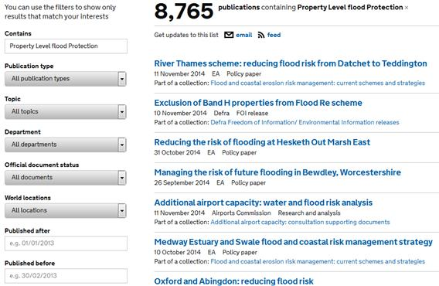
Figure 1a; example of search results, Defra Publications website page.
Search term; ‘Property Level Flood Protection’.
Search filter; All locations
Search date; 11/11/2014.

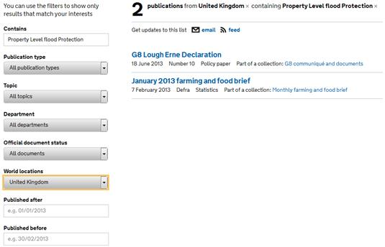
Figure 1b; example of search results, Defra Publications website page.
Search term; ‘Property Level Flood Protection’.
Search filter; United Kingdom
Search date; 11/11/2014.

Property Level Protection and Flood Resilience; available information
Property level flood protection is exactly what it says; flood protection is undertaken at a property level for an individual property. In order to achieve this effectively, a householder is required to have a reasonable understanding of the likelihood of flooding at their property, and the depths and duration that flooding may occur for. Additionally, an understanding of how flood waters may enter and damage a house are also required, as this will influence what flood protection options can be used. The difficulty for both the public and non-expert professional looking for water and flood information is accessing pertinent, current and trustworthy information; it is not that flood-related information is in short supply, its the accessibility and terms used to describe and categorise it that affects search results.
‘Property level flood protection’ is a concept neither seemingly understood nor in common public usage, more frequently being used by flood professionals. Not only does this have consequences for the public in accessing information, a search of UK organisations for documentation on property level flood protection produces comparatively few results. Most of these emanate from government agencies and organisations, or consultants undertaking work on behalf of government and its agencies. Such information is useful in respect of policy, but less so in terms of information for actual property flood protection. Exceptions include ‘Six Steps to Flood Resilience. Guidance for local authorities and professionals’ and ‘Six Steps to Flood Resilience. Guidance for property owners’, although these documents refer to flood resilience, not property level flood protection.
Unless they have been flooded, householders are possibly less familiar with phrases such as ‘property level flood protection’, ‘flood mitigation’, ‘flood resilience’ or ‘flood contingency planning’. However, ‘property flood protection’ and ‘flood protection’ are more understandable as layman’s terms, and consequently produce more useable (if excessive) results from internet searches. As well as commercial companies advertising their products, Google search terms such as ‘flood protection’ and ‘property flood protection’ will direct users to sites such as the National Flood Forum, directly to the National Flood Forum’s ‘Blue Pages’, a directory of property flood protection products, and also to ‘The Kitemark - flood protection’ webpage. Operated by the British Standards Institute, this latter site provides information on certified property flood protection products. Websites such as these provide direct links to flood protection information, enabling householders gain a better understanding of flooding and protecting properties from flooding, and to assess products and undertake property level flood protection. Figure 2 details the National Flood Forum’s ‘Home’ and ‘Blue Pages’ webpages.

Accessing and making use of flood-related information
The difficulty of accessing information via generic search engines is mirrored in websites created to demonstrate flood-related projects and their outcomes. Who outside of the immediate project knows the project exists? And how can information be accessed? This is further compounded when projects become archived and information is no longer available, or links to projects and their outputs no longer function due to project or organisation closure. In the course of this project, numerous flood management documents previously available via website links are no longer available due to the link being broken and the project having finished.
Placing data on a website is not the same as making it accessible. It is not simply that there is an excess of data available, nor that it is of varying quality or designed for specific audiences. Rather, it would seem to be that organisations do not consider how an individual may locate data and what the data is required for. Frequently, data is inappropriately categorised or titled. Thus search filters can exclude data that should be included (as illustrated in Figure 1), whilst common, layman’s terms can clash with professional and industry terms. For a householder trying to find information on property flood protection, the source of flooding is less important; water is water. For a non-water expert but professional user (e.g. emergency responders, urban planners), the distinction between river, sewer and surface flooding will dictate how they respond to or plan for flood events. These different approaches will influence the language used, and so the search terms used. Databases and search tools should therefore be designed with this in mind, catering for all users.

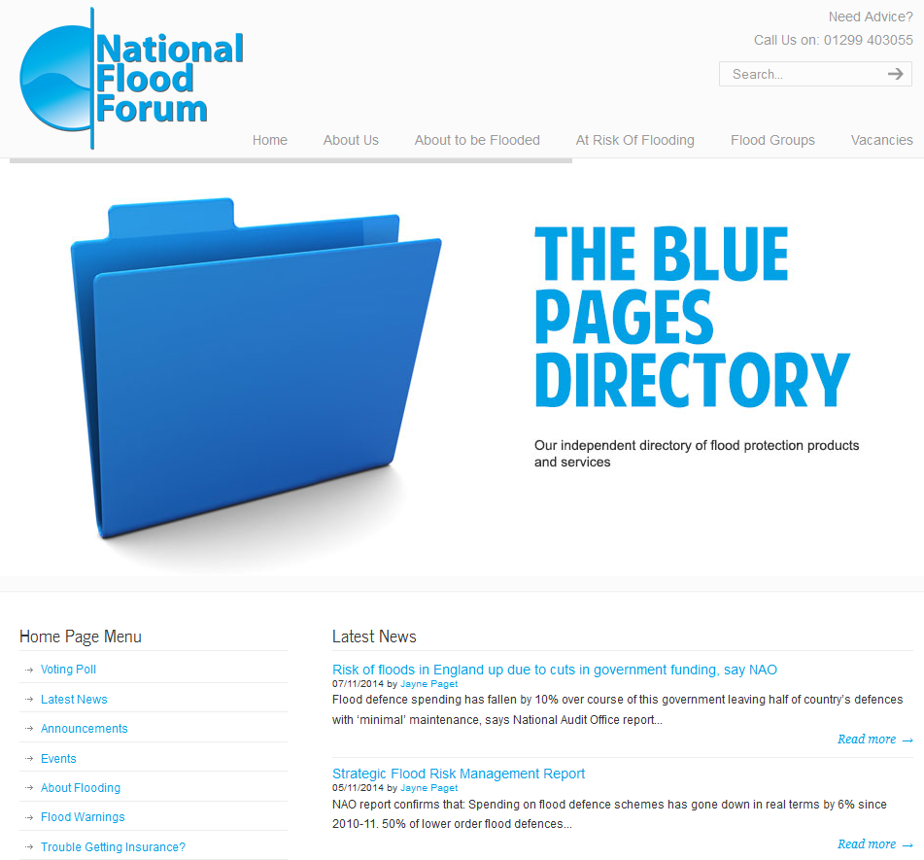 | 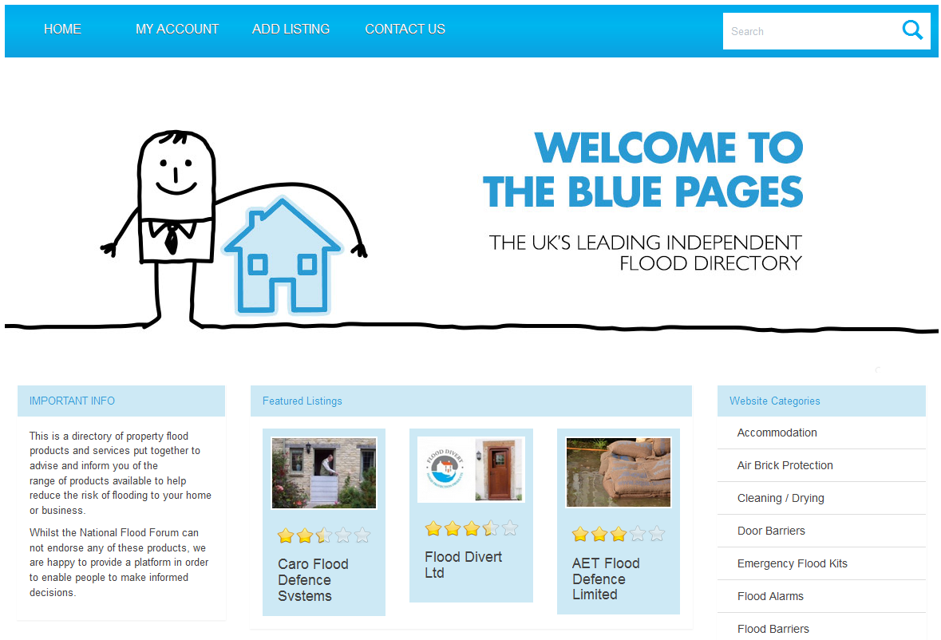
Figure 2; National Flood Forum webpages;
National Flood Forum Homepage showing link to Blue Pages (left)
Blue Pages flood protection product directory Homepage (right)

What is required with respect to output from the various UK and EU water and flood management-related projects including property level flood protection is a directory similar to the National Flood Forum’s ‘Blue Pages’; a repository within which water and flood management information from a range of sources can be stored that is easy to locate, access and understand. The difficulty in this is creating a website and database that enables the search for and location of information using expert or water industry terms as well as more common and generic terms as used by non-experts and the public. Whilst some reports produced by EU projects are aimed at either experts and water industry personnel or the public, many are useful to both. Thus no matter what search terms are used, expert or non-expert, the search should lead to the same reports and documentation. Key to this is categorising reports and documentation in ways which make sense to water experts and non-experts alike so that experts can target searches specific to their requirements, whilst non-experts can use more broad terms that still provide informative search results.
-------------------

EU and UK projects that currently provide information on water and flood management topics with varying degrees of success.

- FRC - FloodResilienCity. http://www.floodresiliencity.eu/
- The BaltCICA Project (Climate Change: Impacts, Costs and Adaptation in the Baltic Sea Region). http://www.baltcica.org/
- MARE - Managing Adaptive Responses to changing flood risk. http://www.mare-project.eu/
- SKINT – Skills Integration and New Technologies. http://www.skintwater.eu/skint/nl/home
- SAWA - Strategic Alliance for Integrated Water Management Actions. http://www.sawa-project.eu/
- The SMARTeST Project. http://www.smartfloodprotection.com/the-smartest-project-2/
- SMARTeST - Flood Resilience Technologies Portal. http://www.tech.floodresilience.eu/

Richard III. Act 5, Scene 4. William Shakespeare, 1594.
Google worldwide search using the term ‘Flooding’. 6,520,000 results returned in 0.29 seconds. Search date; 10/11/2014.
White, I. (2013). The more we know, the more we know we don’t know: Reflections on a decade of planning, flood risk management and false precision. Planning Theory & Practice. Vol. 14, No. 1, pp106-114.
Ditto.
Scott, M. (2013). Living with Flood Risk. Planning Theory & Practice. Vol. 14, No. 1, pp103-106.
Defra. GOV.UK. Publications. Search; Property Level Flood Protection. 11/11/2014. https://www.gov.uk/government/publications?keywords=Property+Level+flood+Protection&publication_filter_option=all&topics[]=all&departments[]=all&official_document_status=all&world_locations[]=all&from_date=&to_date=
Google worldwide search using the term ‘Property Level Flood Protection’. 1,540,000 results in 0.39 seconds. UK only search; 28,900 results in 0.27 seconds. Search date; 11/11/2014.
Google worldwide search using the term ‘Property Level Flood Protection’. 318,000 results in 0.46 seconds. UK only search; 28,700 results in 0.52 seconds. Search date; 12/11/2014.
Property Level flood Protection (PLP) is synonymous with and is commonly used to encompass the term Property Level flood Resilience (PLR).
Bichard, E & Kazmierczak, A. (2012). Are homeowners willing to adapt to and mitigate the effects of climate change? Climate Change. Vol.112 (3-4), pp.633-654.
The SMARTeST Project. http://www.smartfloodprotection.com/the-smartest-project-2/
National Flood Forum. http://www.nationalfloodforum.org.uk/
National Flood Forum ;Blue pages’. http://www.nationalfloodforum.org.uk/bluepages/
The Kitemark - Flood Protection. http://www.kitemark.com/products-and-services/building/flood-protection.php

