Property Level Flood Protection; a guide to locating information on flood protection measures.

  - Simon Doncaster and John Blanksby – Pennine Water group, Department of Civil and Structural Engineering – University of Sheffield

Contents
Introduction 1
Property Level Protection 2
Identifying potential sources of flooding at Location X? 2
To identify potential sources of flooding at Location X in England; 3
Take pre-emptive action 3
Reducing flood damage; identifying suitable PLP actions and measures 4
Assessing property flood resistance 6
Locating PLP devices 6
Property Protection Advisor 8
Flood and PLP information via Rotherham MDC web pages 11
Example PLP; Rotherham Metropolitan Borough Council, Riverside House, Main St. 12
Appendix 17
EU-supported and other water and flood management projects 18
Selected Property Level Flood Protection and Local Flood Management reports 20

Introduction
This guidance document introduces the main steps required to identify the likelihood or risk of flooding for a given location, and where information about Property Level flood Protection (PLP) may be found. Information on flooding and PLP can be found in many places, but this guidance sets out to identify information from a small number of excellent sources at European, National and Local scales. Although the information in this document is set within the context of Rotherham MBC in the UK, it provides a template for similar guidance elsewhere in Europe.
An example PLP assessment using Rotherham Metropolitan Borough Council’s Main Street offices is detailed in the second part of this document.
In addition to web-links and information sources provided in the text, tables are provided in the appendix that detail further documentation on property level flood protection and more general local flood management. The documents detailed are an example of the range of information available, and are presented as a ‘living’ document to be added to as and when by users as suitable for their particular requirements.
Example information sources;
- European Union; Frequently legal and policy documents (e.g. the Water Framework and Floods Directives), but also via EU-funded flood projects. Information varies from country to country, but is often based around a single piece of legislation (e.g. the Floods Directive) and ranges from research to practical guidance documents for those susceptible to flooding.
- UK - Government; Defra, the Environment Agency and local authorities. Linked to EU and UK government legislation and tailored to local situations, e.g. each local authority will have its own flood management plan and will provide flood information for its residents, whilst the Environment Agency provides flood maps and flood information for England and Wales.
- UK - Non-government; Many organisations provide information on flooding, from local community flood groups, university research groups and to nationwide charities such as the National Flood Forum. Information varies in content and quality but is a useful source of simple, readily accessible advice for the public.
- UK - commercial; Many commercial organisations provide information on flooding and its effects, albeit with the intent of selling products and services. These range from consultancy organisations assessing flood likelihood and associated risk to companies manufacturing and selling flood defence products. Information varies in content and quality, but can be useful in gaining an understanding of options for PLP.
- Worldwide; Much PLP information is available from worldwide sources. However, the context of flooding may be very different from the UK, so whilst information can be useful to gain a greater understanding of flooding and options available, it should be viewed from the context of the source county.

Property Level Protection
“Property-level protection is all about the measures we can take to protect our homes from flooding.”
Property Level Protection is the taking of measures at the level of an individual property that aim to reduce a buildings susceptibility to flooding and subsequent flood damage. This includes flood resistant measures that aim to prevent flood water entry into a building, and flood resistance measures that aim to minimise damage once flood waters have entered a building. The implementation of these measures is usually the responsibility of the building owner (although they may also have been installed during building construction) although assistance may be available from some local authorities, depending on local conditions. A short guide to PLP can be found on the National Flood Forum website;
http://nationalfloodforum.org.uk/wp-content/uploads/PropertyprotectionPLPfolded-PM.pdf

Identifying potential sources of flooding at Location X
It is a myth that flooding only comes from rivers and the sea. Understanding what the sources of flooding are and the likelihood of flooding is at a given location enables the flood risk to be properly assessed and action to be taken. Note that flooding may occur from more than one source at any given time.
Flood sources;
- watercourses - natural, modified and manmade (rivers, streams, culverted rivers/streams, channelised rivers/streams, canals and similar)
- Drainage networks (drains, sewers, ditches, dykes and similar).
- Water bodies (lakes, reservoirs, ponds, wetlands)
- Coastal - i.e. flooding from the sea and estuaries
- Surface flooding - flooding following rainfall and/or rapid snowmelt where water flows over the ground
- Groundwater flooding - water rises up from the ground due to saturation and high water table levels
- Also; flooding cause by leaks and bursts within water distribution systems; an irregular occurrence and usually repaired quickly if causing damage or risk to property and individuals. This is not covered in this document.

To identify potential sources of flooding at Location X in England;
Note: Flood maps only indicate land that is likely to flood and may provide information on the frequency, depth and velocity of flood waters. They do not provide information on the extent of damage to property
- Use the Environment Agency Floodmap to assess sources of flooding at your location; Accessible via; https://www.gov.uk/floodsdestroy then click on ‘Environment Agency’s maps’.
- Enter post code or place name, select the type of flood map required (Figure 1a) and then ‘Go’. The resultant map will detail areas at risk of flooding for the type of flooding you specified (Figure 1b; surfaced water flooding)
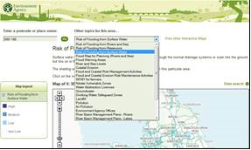
Figure 1a; Select location and flood type
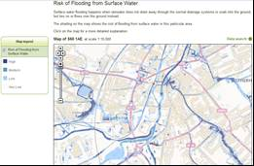

Figure 1b; Result for surface water flood map, Rotherham city centre
For further information related to current weather forecasts and flood warnings, see; https://www.gov.uk/check-if-youre-at-risk-of-flooding.
Further information on flood risk areas may also be available from the Local Authority website.

Take pre-emptive action
Having identified flood sources and risk, take action to prepare for flooding. This should be done regardless of any action taken to mitigate flooding and flood damage to property; flood defences and property protection devices can be overwhelmed by flood waters. PLP does not guarantee that flooding and flood damage will not occur at or in any given property.
To reduce the risk of being caught unawares by flooding and to prepare for a flood, sign up to the Environment Agency’s ‘Flood Warnings Direct’ via the free floods warning service and the ‘Prepare a personal flood plan’ links via;
https://www.gov.uk/floodsdestroy
and also;
https://www.gov.uk/prepare-for-a-flood.
Also see information provided by the National Flood Forum on preparing for a flood and action to take;
National Flood Forum; http://www.nationalfloodforum.org.uk/
and;
http://www.nationalfloodforum.org.uk/at-risk-of-flooding-2/preparing-for-a-flood/
Similar information may be provided by local authorities. Note, however, that depending on the perceived flood risk or history of flooding in a local authority area, the local authority organisational structure and the design of a given local authority website, locating information on flooding may not be straightforward. When searching local authority websites for flood information, as well as using search terms such as ‘flooding’ and ‘flood’, flood information may be found under ‘emergency planning’, ‘environmental services’, ‘drainage’, ‘emergencies’ and similar. Locating, bookmarking and saving local authority website flood information prior to flooding is recommended. Note also that local authority flood information may only refer to what to do in an emergency. Information on pre-emptive PLP may not be available.

Reducing flood damage; identifying suitable PLP actions and measures
Having gained an understanding of the likelihood and risk of flooding, individual properties should be assessed as to their current resistance and resilience to flooding and flood damage, and thence what action could be taken to increase flood resistance and resilience.
Flood resistance; measures that aim to prevent floodwaters from entering a building (e.g. air brick and door guards). Sometimes known as dry proofing and flood protection&.
In some cases such as terraced properties, measures to protect the periphery of the whole block may be appropriate.
Flood resilience; use of construction and building materials that are resilient to water damage (e.g. waterproof plaster, concrete floors), and construction methods that reduce flood damage in the first instance (e.g. high level electrical circuits and raised appliances). Sometimes known as wet proofing&.
Flood resistance and flood resilience measures are most effective when used in combination, with measures from either approach being used to support the other. Flood resilience measures are easier to apply during the construction of new buildings or during repairs following flooding as they often include major construction elements&, e.g. installing concrete ground level floors and water resistant plaster and electrical circuits. Flood resistance measures can be installed on existing buildings without requiring major construction work.
Further information on flood resilience and resistance can be found via; http://archive.defra.gov.uk/environment/flooding/documents/manage/frrs-scope.pdf
and;
http://nationalfloodforum.org.uk/wp-content/uploads/20140519-PLP-Advice-for-Local-Authorities.pdf
via the IWA Water Wiki;
http://www.iwawaterwiki.org/xwiki/bin/view/Articles/FloodAdaptiveArchitecturedryproofingwetproofingAquatecture

It is important to understand that whilst flood resistance measures will prevent or slow flood waters from entering a house, should flood waters become deep (around 600mm/24inches) then flood waters should be allowed to enter properties due to the risk of structural damage caused by external water pressure on property walls. Allowing water to enter a property will balance external pressure although damage could still occur due to high flow velocities and debris contained within flood waters.

Assessing property flood resistance
To reduce flood damage, properties should be assed to identify locations where flood waters may enter. Such entry points include but are not exclusive to;
- Air bricks
- Doorways and windows
- Drains via backflow, e.g. bathroom and toilet drains
- Under floor voids at ground level
- Cellars and basements
- Permeable and poorly maintained brick and stonework
- Entry and exit points of cables and pipes if not properly sealed
- Shared party walls where neighbouring properties have not been made flood resistant and have subsequently flooded.

Buildings should be assessed by individuals appropriately qualified and experienced and with an understanding of the effects of flooding on property.
Further information can be found directly via the SMARTeST project website; http://www.tech.floodresilience.eu/
and via;
Smart Flood Protection - Home – Flood protection & resilience; http://www.smartfloodprotection.com/
From the Smart Flood Protection website, the following documents can be downloaded;
6 Steps to Property Level Flood Protection - Guidance for property owners; http://www.smartfloodprotection.com/wp-content/uploads/dlm_uploads/2014/09/property_owners_guidance_revised.pdf
Six Steps to Flood Resilience – Guidance for local authorities and professionals; http://www.smartfloodprotection.com/wp-content/uploads/dlm_uploads/2014/02/Six-Steps-LA-Professional-web-v3-July2014.pdf

Locating PLP devices
Many companies offer PLP services and devices, and these devices range from the simple and temporary, e.g. sandbags, to more complicated and permanent devices, e.g. passive, self-activating flood-resistance air bricks and anti-backflow valves for toilets and foul drains. The predominant sources of flooding at a given location may indicate what PLP measures are most appropriate. For example water standing outside buildings can result in leakage through brickwork, poorly fitted door frames and other apertures and groundwater flooding may best be managed by pumping. Installation of many PLP devices can be undertaken by property owners. However the more complicated devices may require professional installation.
Quality, effectiveness and cost all vary within PLP devices. The purpose of PLP means that it is often only fully tested during floods, at which point it is too late to replace ineffective or poor quality protection devices. Thus viewing a range of devices and seeking professional and impartial help is recommended before purchases are made.
In order to give an indication of quality and being fit for purpose, the British Standards Institute has begun a testing procedure for flood protection products. PLP devices that meet the required standards will be given a BSI Kitemark and thus are deemed to have been tested and considered fit for purpose. Whilst this does not mean that non-Kitemarked devices are not fit for purpose, nonetheless the Kitemark symbol indicates a product has been tested and a quality standard met, thus giving some independent assurance that the product will operate as claimed by the manufacturer. Some insurance companies may insist on Kitemarked products being used.
For further information on BSI Kitemarked PLP products, see;
http://www.kitemark.com/products-and-services/building/flood-protection.php

Whilst an internet search will locate numerous companies selling PLP devices, organisations such as the National Flood Forum have produced a directory of flood protection companies, services and products from which the public can obtain information. Example directories and information sources include;
The Blue Pages. http://www.bluepages.org.uk/
and via; http://www.nationalfloodforum.org.uk/bluepages/

Additional information on PLP devices and flood protection in general can be found via commercial and trade representative organisations, e.g;
The Flood Protection Association. http://thefpa.org.uk/
FADS Directory. http://www.fadsdirectory.com/index
Once PLP devices have been identified and purchased, they should be fitted by competent and if necessary qualified personnel to ensure correct operation, that building regulations are met and to meet any insurance company conditions. If possible, they should be tested for operation and effectiveness. Following fitment, PLP devices should be maintained and regularly tested to ensure their continued operation.

Property Protection Advisor
The National Flood Forum provides an on-line service that provides estimates of the cost of providing PLP for dwellings. This is based on research commissioned by Defra and depends on the type of dwelling and its construction. The Property Protection Advisor can be accessed via;
http://www.nationalfloodforum.org.uk/flood-protection-adviser/
On accessing the Property Protection Advisor, select the ‘Cost’ button (or ‘Retrieve Costs’ as required) (Figure 2a). This opens the ‘Basic Property Information’ web page.
1) Enter property address, post code and property type (Detached, semi-detached, terrace etc.). Figure 2b.
2) Select ‘View Report’. This produces a generic PLP Appraisal Report that provides indicative PLP costs for the type of property detailed, similar to Figure 2d. OR;
3) Select ‘Continue’. This opens a page enabling more detailed property information to be provided (Figure 2c). Providing as much detail as possible will produce a more targeted PLP Appraisal Report, as detailed in Figure 2d.
The Appraisal reports generated are in pdf format and can be saved. The report contains cost estimates for various PLP devices and details assumptions that have been made in the calculations. PLP and its benefits are described, and following steps to take briefly detailed. Contact details for further flood and PLP information are also given, including links the National Flood Forum’s Blue Pages PLP directory.
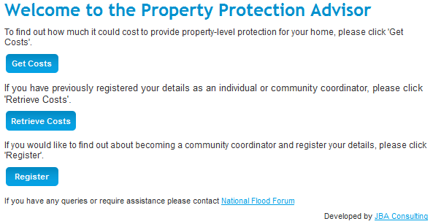
Figure 2a; Front page of the National Flood Forum’s Property Protection Advisor
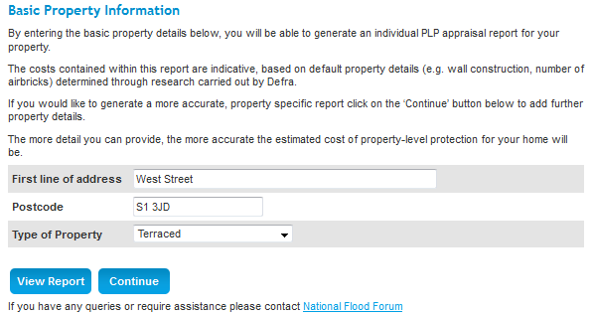
Figure 2b; Basic Property Information page
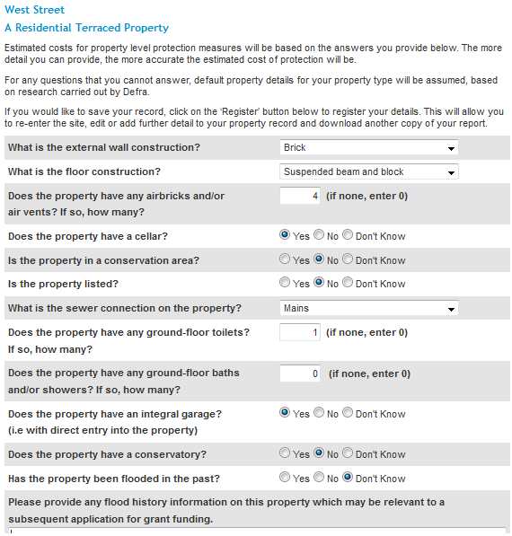
Figure 2c; Detailed Property Information page
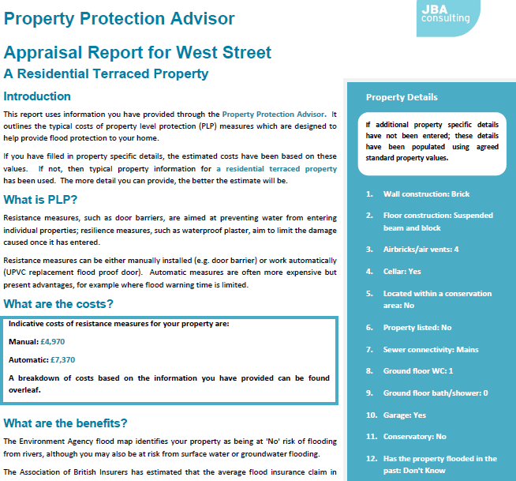
Figure 2d; Example PLP Appraisal Report using detailed property information

Flood and PLP information via Rotherham MDC web pages
Links from the Rotherham MDC website also connect with flood and PLP information. This can be accessed via a search for ‘Flooding’ on the RMDC webpage, then from the search results;
select the link; Flooding - South Yorkshire Emergencies
This will open the ‘Flooding’ web page of South Yorkshire Emergencies; http://www.rotherham.gov.uk/emergencies/info/2/risks/46/flooding
From the ‘Flooding’ page, locate and select the flood protection products link under the paragraph ‘During a flood’. This will link to the GOV.UK ‘Prepare for a flood’ web page;
https://www.gov.uk/prepare-for-a-flood
From this, a range of flood information can be found, including links to Environment Agency flood maps. Selecting the ‘Improve you properties flood protection’ link will provide links to further services, including locating building surveyors and architects as well as providing a link to the National Flood Forum’s ‘Flood Protection Advisor’ web page;
http://www.nationalfloodforum.org.uk/flood-protection-adviser/

Example PLP; Rotherham Metropolitan Borough Council, Riverside House, Main St.

1) Identify and assess flood sources at Riverside House using the Environment Agency flood maps either via;
GOV.UK; https://www.gov.uk/floodsdestroy and then select ‘Environment Agency’s maps’.
or via the Environment Agency flood map page directly;
http://maps.environment-agency.gov.uk/wiyby/wiybyController?x=357683.0&y=355134.0&scale=1&layerGroups=default&ep=map&textonly=off&lang=_e&topic=floodmap
NOTE; RMDCs own website provides flood information and flood maps. However, these maps relate to current flood warnings, flood alerts and imminent flood risk. They do not (as yet) provide information on sources of flooding. See;
http://www.rotherham.gov.uk/emergencies/site/ and select ‘Flood Map’.
2) Having accessed the Environment Agency’s Flood maps web page, enter the post code for Riverside House (S60 1AE) and then select the type of map data required. Then ‘Go’ and repeat as necessary for additional maps. Zoom into target location to see close up detail, Figure 3.
For a full understanding of flood sources, create a map for each of the flood sources available;
  - Risk of flooding from Rivers and Sea
  - Risk of flooding from Reservoirs
  - Risk of flooding from Surface Water
Note that there are additional flood maps which may prove useful;
  - Flood Map for Planning (Rivers and Sea)
  - Flood Warning Areas
  - River and Sea Levels
  - Flood and Coastal Risk Management Activities
  - Flood and Coastal Erosion Risk Maintenance Activities
  - Groundwater
  - River Basin Management Plans (5 off; Rivers, Lakes, Estuarine, Coastal and Groundwater
Select location (S60 1AE) and flood type | 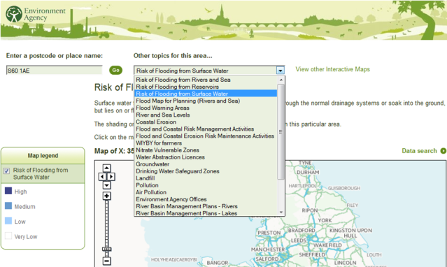 | 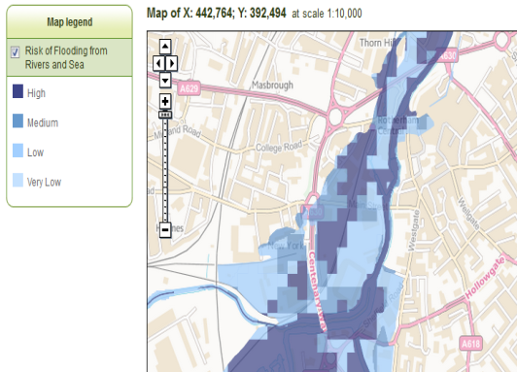 | Risk of Flooding from Rivers and Sea
Risk of Flooding from Reservoirs | 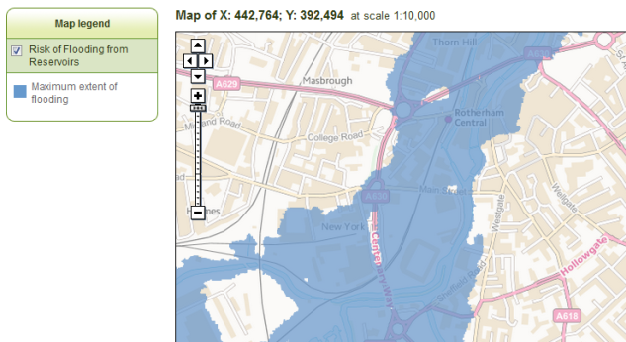 | 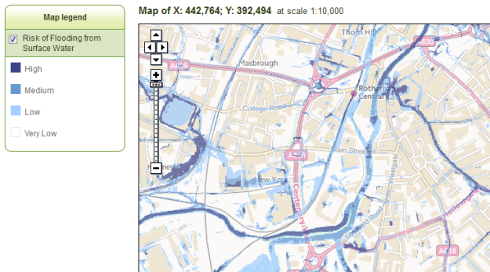 | Risk of Flooding from Surface Water
Flood Map for Planning  (Rivers and Sea) | 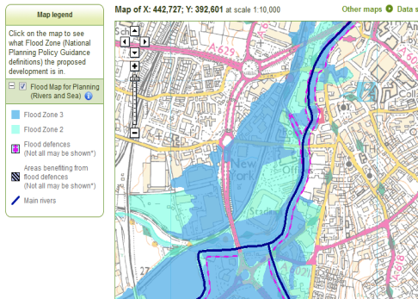 | 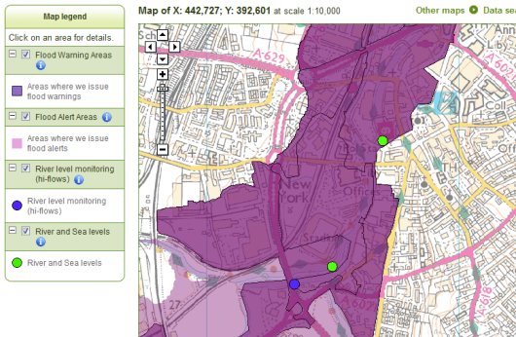 | Flood Warning Areas
Figure 3; Example Environment Agency flood source and warning maps for central Rotherham. Riverside House location; ●

Having identified the flood risk for Riverside House, and presuming emergency flood plans are in place and that RMDC has signed up for the Environment Agencies Flood Alert system (See https://www.gov.uk/floodsdestroy), Riverside House requires assessing for flood resistance.
(Flood resilience; Flood resilience requires building construction or repair using flood resilient materials and procedures. It is assumed that flood resilience has been built into Riverside House. Flood resistant measures can also be used to aid flood resilience. For further information, see; http://archive.defra.gov.uk/environment/flooding/documents/manage/frrs-scope.pdf
and;
http://nationalfloodforum.org.uk/wp-content/uploads/20140519-PLP-Advice-for-Local-Authorities.pdf )

3) Assessing Riverside House for flood resistance.
Assessment of Riverside House requires careful consideration of where flood waters may enter the building. This assessment should be conducted by a qualified and competent person. Flood water entry points include;
- Air bricks
- Doorways and windows
- Drains via backflow, e.g. bathroom and toilet drains
- Under floor voids at ground level
- Cellars and basements
- Permeable and poorly maintained brick and stonework
- Entry and exit points of cables and pipes if not properly sealed
- Shared party walls

These entry points should be checked for their susceptibility to flood water entry, and suitable flood resilient devises installed by qualified personnel, e.g;
- Air bricks; temporary and demountable or passive, self-setting air brick guards.
- Doorways; demountable door guards
- First floor windows; demountable window guards
- Vehicle access points into buildings, e.g. loading bays at or below ground level; demountable barriers, flood-proof doors, tanked and sealed surfaces
- Drains (e.g. toilets, showers, washing machines, kitchen sinks etc.); one-way, non-return valves fitted to ground level and sub-surface drains leading from the building
- Under floor voids, cellars and basements; if not already made flood resistant during construction (i.e. via tanking and using waterproof materials), then seal all joints and surfaces and install a sump and pump to remove flood waters that may enter. Additional demountable guards at the top of stairways or lift shafts may prevent floodwater flows within the building from entering basement levels
- Permeable and poorly maintained brickwork; external tanking and waterproof coatings up to a height not likely to be exceeded by flood waters. Additional and temporary demountable flood barriers placed around or fixed to the building for additional defence
- Entry and exit points of cables and pipes if not properly sealed; identify all points of entry and exit of cables and pipes at or near ground level and seal with appropriate material, e.g. waterproof foams and sealants. If possible, raise entry points to above maximum flood height and seal off existing entry points
- Floor to wall joints, door and window to wall joints and similar; seal with waterproof foams and sealants
- Shared party walls. Shared party walls place an element of cooperation on the parties. Taking flood resistant measures on one side of a wall alone will help slow flood water entry, but may not prevent it. Cooperation between parties will be necessary for flood resistant measures to be fully effective.
Note that due to due to hydrostatic pressure, saturated ground and high water table levels (groundwater), water ingress may occur within buildings in spite of and behind PLP measures. Measures should therefore also be taken to raise items at risk of flooding to above the maximum predicted flood height. This will also be of benefit should external flood waters over-top external flood defences.

Further, general information and options available can be found from;
6 Steps to Property Level Flood Protection - Guidance for property owners; http://www.smartfloodprotection.com/wp-content/uploads/dlm_uploads/2014/09/property_owners_guidance_revised.pdf
Six Steps to Flood Resilience – Guidance for local authorities and professionals; http://www.smartfloodprotection.com/wp-content/uploads/dlm_uploads/2014/02/Six-Steps-LA-Professional-web-v3-July2014.pdf

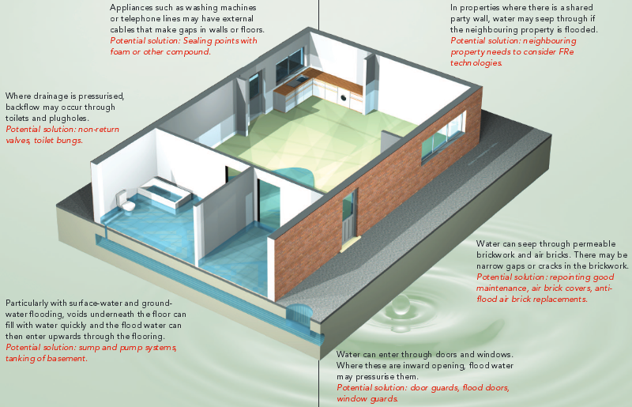
Figure 4; Illustration of potential flood water ingress points within a property.
From; White, I., Lawson, N., O’Hare, P., Garvin, S., and Connelly, A. 2012.
Six Steps to Property Level Flood Protection – Guidance for Property Owners. Manchester, UK.

Information and directories on PLP measures, manufacturers and suppliers can be found via;
The National Flood Forum ‘Blue Pages’;
http://www.bluepages.org.uk/
http://www.nationalfloodforum.org.uk/bluepages/

The SMARTeST Products and Technologies web page (Registration may be required);
http://www.tech.floodresilience.eu/directory
and from the PLP product and service directory summary r2 140805 from JB, weblink to be established.

Commercial PLP directories include;
The FADS Directory; http://www.fadsdirectory.com/index
Internet searches will provide further information on PLP measures and suppliers.

Appendix

The tables contained within the Appendix contain brief descriptions of and web-links to reports and documentations related to property level flood protection and more general local flood management. These documents have been sourced from the UK and EU. Additionally, links are provided to EU-supported and other water and flood management projects that contain a wealth of information for both expert and non-expert user. Neither the reports nor project websites detailed are exhaustive, being only an indication of information available on water and flooding.

EU-supported and other water and flood management projects

Project | Project description | Web-site link
BaltCICA - Climate Change: Impacts, Costs and Adaptation in the Baltic Sea Region | Project focussing on the most imminent problems that climate change is likely to cause in the Baltic Sea Region, including water and flood management, through assessing the costs and benefits of adaptation using case studies and on a pan-Baltic level. | http://www.baltcica.org/
CAMINO - Climate Adaptation Mainstreaming through Innovation | The overall aim of CAMINO is to reconcile economic growth and climate adaptation in the North Sea Region. It will do so through identification of innovative governance structures and approaches to the development of business cases that support mainstreaming climate adaptation in local investment projects and product/service development. CAMINO will bring together results of MARE, SKINT, SAWA (all NSR), FRC (NWE) and BaltCica (BSR) and enrich existing public-private Partnerships to support and accelerate the implementation of over 10 innovative cases in urban and business development. | http://camino-project.eu/
FRC - FloodResilienCity | Developing urban areas that are able to be resilient to changes that would otherwise cause an increasing likelihood of flooding | http://www.floodresiliencity.eu/
MARE - Managing Adaptive Responses to changing flood risk | The MARE project aims to contribute to the development of a framework and resources by developing and demonstrating a practical, transnational methodology to implement urban Flood Risk Management. | http://www.mare-project.eu/
SAWA - Strategic Alliance for Integrated Water Management Actions | SAWA aims to develop strategies which will adhere to the European Water Frame Directive and meet the requirements of the Floods Directive, enabling a flexible approach to water management and potential climate change impacts | http://www.sawa-project.eu/
SKINT – Skills Integration and New Technologies | Facilitates the implementation of sustainable urban land and water management by improving the integration of water management and spatial planning processes. SKINT contributes to fulfilling Water Framework and Flood Directives objectives of improving water quality and reducing flood risk in urban areas | http://www.skintwater.eu/
SMARTeST | Flood Resilience Technologies Portal with the aim of providing information and knowledge on Flood Resilient Measures based on existing and innovative technologies. SMARTeST is motivated by the new EU flood risk management policy of ‘Living with Floods’, a relatively new approach towards flooding requiring new approaches and understanding of flooding, flood management and flood resilience. | http://www.tech.floodresilience.eu/

Selected Property Level Flood Protection and Local Flood Management reports
Organisation | Organisation type | Country | Date | Document title | Abstract-Description | Website Link  (link may not be website of publishing organisation)
CEPRI (Européen de Prévention du Risque d'Inondation) | Flood research organisation | France | 2010 | CONSTRUCTION IN FLOOD-PRONE AREAS. VULNERABILITY OF BUILDING STRUCTURES | Document providing information on identifying the effects and damage caused by flooding to a building, how to recognise the effects and potential damage and what repairs may be most suitable. Also included is information on potential risk to human safety and how damage to a building may affect other buildings and prevent a return to normal activity. | https://docs.google.com/viewer?a=v&pid=sites&srcid=c2hlZmZpZWxkLmFjLnVrfGpyYmludGVycmVnfGd4OjYxZDgxMjhjZGMyMDM1NTQ
CIRIA (Construction Industry Research Association) | Construction industry research | UK | 2005 | Standards for the repair of buildings following flooding (CIRIA C623) | Guidance document detailing requirements and procedures for the repair of buildings following flooding. Intended for construction and insurance professionals but also useful for householders, surveyors and general builders, the document contains illustrations, information on making buildings safe, drying, decontaminating and repairing buildings using appropriate methods and increasing building flood resilience. | Available free from the CIRIA website; http://www.ciria.com/flooding/July07_news.htm
Communities and Local Government | Government | UK | 2007 | Improving the flood performance of new buildings. Flood resilient construction | Document providing information and recommendations on improving flood resilience in new buildings through the use of appropriate materials and procedures. The document is designer for developers and building designers, but will also be useful to planners, insurers and building control personnel. The guidance is primarily aimed at development in flood zones of low or residual risk (Flood Zone 1) and areas where flood mitigation measures have been installed. | http://www.planningportal.gov.uk/uploads/br/flood_performance.pdf
Defra | Government | UK | 2014 | Best Practice in Property Level Protection Systems. Advice for Local Authorities | Document providing advice for local authorities in the delivery of property level flood protection measures, detailing good practice and examples of implemented and successful schemes. | http://nationalfloodforum.org.uk/wp-content/uploads/20140519-PLP-Advice-for-Local-Authorities.pdf
Defra | Government | UK | 2008 | Consultation on policy options for promoting property-level flood protection and resilience | Consultation document on PLP promotion. Detailing recent flood incidents in the UK, the documents presents options to increase the uptake of PLP measures, noting that voluntary uptake of such measures is limited. In addition to PLP uptake and barriers preventing PLP uptake, resilient repair and refurbishment of properties are discussed. A summary of consultation questions is provided. Issues noted include lack of flood awareness, assumptions that the State will provide protection, and negative impacts on property saleability. Options to increase PLP uptake presented include free advice and financial assistance. An evidence base for arguments contained within the document is provided in an annex. | http://www.biba.org.uk/PDFfiles/DEFRAFloodProtectionResilianceconsultation.pdf
Environment Agency | Government | UK | 2009 | Prepare your property for flooding. A guide for householders and small businesses | Short document giving basic, concise advice on preparing homes and businesses for flooding. | https://www.gov.uk/government/uploads/system/uploads/attachment_data/file/292943/geho1009brdl-e-e.pdf
Environment Agency | Government | UK | 2012 | Guidance; Completing the Flood Risk Report following provision of Property Level Flood Protection measures 2012  Property flood protection: flood risk report - Guidance document, template document and example documents | Four documents provided by the Environment Agency for completion of a Flood Risk Report for property level flood protection. The guidance document provides information on the flood risk report template and use and completion of a flood risk report. The flood risk report enables the inclusion of details of flood risk (for a given property) with protection measures installed, potential sources of flooding and flood risk from those sources, protection measures provided and related flood resistance and resilience, flood history of the property and guidance for the property owner. The flood risk report/template document concludes with a glossary, whilst the two example documents show what a completed flood risk report should contain. | All 4 documents are contained within a downloadable WinZip folder and are accessible via;  https://www.gov.uk/government/publications/property-flood-protection-flood-risk-report
Environment Agency | Government | UK | 2011 | Practical Guidance for Property Level Flood Protection | Guidance document detailing property level protection in relation to flood resistance (not resilience). The document is primarily aimed at Environment Agency managers and for EA managed projects, and is based on practical experience. Covered in the guidance are project appraisals; is the site/property suitable, what are the risks, cost/benefit and financial considerations (including who pays, grants etc.), property condition, flood resistance products, procurement frameworks and ensuring property surveys and PLP measures are undertaken and installed by qualified personnel. Appendices include PLP process flow charts, examples of Kitemarked flood resistance products, national Framework suppliers and a household level flood protection survey template. | https://gateway.asite.com/exchange/dpd?actionId=11&id=2851320$$0us3Cd&p_id=50171$$Bi5QfY&type=1&doc_ref=Property_level_protection_guidance
Environment Agency | Government | UK | 2010 | Review of the Pilot Flood Protection Grant Scheme in a Recently Flooded Area. R&D Technical Report FD2651/TR. | This report describes the findings of research conducted in the Cumbrian town of Appleby-in-Westmorland that flooded shortly after residents and businesses were provided with grant-funded property-level flood protection measures. It looks at issues around the implementation of the grant scheme, its consequences for the impact of the flood and, in the longer term, for attitudes to flood protection and resilience. The lessons of this study are of relevance to any local, regional or national organisation that wishes to encourage individuals to take practical measures to reduce their exposure to flood risk. | http://eprints.kingston.ac.uk/18085/1/Appleby_technical_report_-_as_published.pdf
Environment Agency | Government | UK | 2012 | Defra Capacity Building Programme: 'Property-level Protection - from pilots to mainstream schemes'. | Document providing background information on PLP and what it encompasses. PLP options and hierarchy are described along with information on initial pilot studies. Grant schemes, funding and cost effectiveness of PLP are given. Partnerships and community engagement issues are identified with barriers to PLP uptake also noted (funding, insurance and awareness). PLP is noted to have raised the 'inclusiveness' of participants (i.e. the public) in flood mitigation works although issues of confidence in PLP are noted to exist. PLP is identified as an option sitting between 'do nothing' and expensive, uneconomic traditional flood defence schemes. | http://nationalfloodforum.org.uk/wp-content/uploads/Report.pdf
Environment Agency | Government | UK | 2009 | Flooding in England: A National Assessment of Flood Risk | Report setting out the main findings of the 2008 National Flood Risk Assessment, with emphasis on the role played by the Environment Agency in tackling the risk of flooding from rivers and the sea in England | https://www.gov.uk/government/uploads/system/uploads/attachment_data/file/292928/geho0609bqds-e-e.pdf
JBA Consulting | Consultant | UK | 2012 | Evaluation of the Defra Property-level Flood Protection Scheme: 25918. Summary Report | Report summarising the findings of an assessment and evaluation of Defra's Property Level Flood Protection Scheme using information obtained from 40 local authorities, stakeholder workshops and reviews of individual property level flood protection schemes and interviews. Cost-benefits have been assessed, with successes and difficulties identified. The report is supported with examples, maps, tables and graphs. | http://nationalfloodforum.org.uk/wp-content/uploads/Evaluation-of-the-Defra-PL-Flood-protection-Scheme-25918.pdf
JBA Consulting | Consultant | UK | 2013 | Chew Magna Property Level Protection Scheme Evaluation. Final Report | Case study report detailing outcomes of Defra's Pilot Study of Property Level Protection at Chew Magna. Located in a rapid response catchment, findings of the Chew Magna project include engagement and willingness amongst stakeholders, artificially raised public expectations, successes of PLP implementation and flooding despite PLP implementation. Issues of PLP measure ownership and maintenance are noted to have impacted negatively on flood mitigation. The report contains details of PLP appraisals and property surveys, details of flood events, public engagement events (flood fairs etc.) and installation of PLP measures and their performance. | http://www.bathnes.gov.uk/sites/default/files/sitedocuments/Streets-and-Highway-Maintenance/Drains/2013s6940_-_chew_magna_plp_evaluation_final_report.pdf
MDA and RAB Consultants | Consultant | UK | 2014 | Homeowners Guide to Flood Resilience. A Living Document | Document detailing why and how home owners should and can protect themselves and their properties from flooding. Provided are details on where flood information can be found, how best to protect from flooding, flood resilience for properties, and community-wide solutions. Case studies are detailed along with a list of flood protection equipment manufacturers and useful links and references. | http://www.knowyourfloodrisk.co.uk/sites/default/files/FloodGuide_ForHomeowners.pdf
Rotherham MBC | Local Authority | UK | 2011 | Community Flooding Booklet.  (Community_flooding_booklet.pdf) | Document outlining flood risk in Rotherham, what flood defences exist and what has been done to alleviate flooding. Details of historic floods are given, along with flood risk assessments, emergency response, roles of flood wardens and who is responsible for what during a flood. This includes action property owners should take, trigger and alert levels and action required at each level. Concise guidance on what to do if warned of and during a flood is provided, along with post flood recovery. The document concludes with a list of useful telephone numbers and websites. | http://www.rotherham.gov.uk/downloads/file/631/community_flooding_booklet
Rotherham MBC | Local Authority | UK | 2014 | Map document; River and Surface water flooding.  (LFRMS App B 187-46-DR001 Rev.A.pdf) | Map detailing river and surface water flooding in the Rotherham area. Data from UK Environment Agency | http://moderngov.rotherham.gov.uk/documents/s93343/LFRMS%20App%20B%20187-46-DR001%20Rev.A.pdf
Rotherham MBC | Local Authority | UK | 2014 | Map document; Locally Significant Surface Water Flood Risk Areas.  (LFRMS App B 187-46-DR002 Rev.A.pdf) | Map detailing localities at significant risk of surface water flooding in the Rotherham area. | http://moderngov.rotherham.gov.uk/documents/s93344/LFRMS%20App%20B%20187-46-DR002%20Rev.A.pdf
Rotherham MBC | Local Authority | UK | 2014 | Policy for Consents or Approval of Works Affecting and Ordinary Watercourse.  (LFRMS App C Policy - Consents for Ordinary Watercourses.pdf) | Local authority Consent document detailing water body definitions, aims of consents and works that may require a consent or approval (if consent not required). Details of the consent process is given in appendices, within information on design guidance, appeals, compliance and enforcement. Details of appropriate legislation are also provided. | http://moderngov.rotherham.gov.uk/documents/s93345/LFRMS%20App%20C%20Policy%20-%20Consents%20for%20Ordinary%20Watercourses.pdf
Rotherham MBC | Local Authority | UK | 2014 | Policy for carrying out Flood Investigations as required by Section 19 of the Flood and Water Management Act 2010 Lead Local Flood Authorities: Duty to Investigate Flooding.  (LFRMS App C Policy - Section 19 Investigations.pfd) | Policy and guidance document outlining duties contained within the Flood and Water Management Act (2010), including investigating flood events as considered necessary. Guidance includes when and what criteria are considered to have been met to instigate investigation of flood events. These include (for Rotherham MBC) frequently occurring minor flooding, critical infrastructure at high flood risk, vulnerable people at flood risk, and internal flooding of 5 or more residential properties. Details and procedures for recording flood investigation are given in appendices. | http://moderngov.rotherham.gov.uk/documents/s93346/LFRMS%20App%20C%20Policy%20-%20Section%2019%20Investigations.pdf
Rotherham MBC | Local Authority | UK | 2014 | Policy for Managing Data Held for Flood Risk Management Purposes.  (LFRMS App C Policy Data and Security.pfd) | Policy document outlining data management requirements for flood-related data. This includes information on photographic and personal data, data on flood maps, modelling and historic flood events, and data from other organisations. Also detailed are comment son maintaining an asset register and the retention of records, including metadata. | http://moderngov.rotherham.gov.uk/documents/s93347/LFRMS%20App%20C%20Policy%20Data%20and%20Security.pdf
Rotherham MBC | Local Authority | UK | 2014 | Policy for Designation of Flood Defence Structures and Features.  (LFRMS App C Policy Designation of Assets) | Policy document detailing the designation of flood defence structures and features, as required by the Flood and Water Management Act (2010). The document details what a designation is (a legally binding notice), what can be designated and the conditions for such. Procedures for designation are given, along with details of consultation, notice and appeal periods. | http://moderngov.rotherham.gov.uk/documents/s93348/LFRMS%20App%20C%20Policy%20Designation%20of%20Assets.pdf
Rotherham MBC | Local Authority | UK | 2014 | Rotherham Local Flood Risk Management Strategy.  (LFRMS Local Flood Risk Management Strategy Final and App A.pfd) | Strategy document detailing assessment of local flood risk, strategic and environmental objectives, potential impacts of climate change and associated predictions, details of funding and funding sources for flood risk management, and discussions of authorities involved in flood risk management in the Rotherham area. In addition to considering flood resilience, the document comments on identified skills gap and reviewing and revising the strategy. The document concludes with an action plan for Rotherham. | http://moderngov.rotherham.gov.uk/documents/s93342/LFRMS%20Local%20Flood%20Risk%20Management%20Strategy%20Final%20and%20App%20A.pdf
Rotherham MBC | Local Authority | UK | 2014 | Rotherham Local Flood Risk Management Strategy; All Wards.  (Local Flood Management Risk Strategy.pdf) | Cabinet meeting report detailing Rotherham MBC recommendations to approve the draft Local Flood Risk Management Strategy. Issues of Duties under the Flood Risk Regulations 2009 and the Floods and Water Management Act 2010 are noted, along with financial and policy issues, and risk and uncertainties. | http://moderngov.rotherham.gov.uk/documents/s93466/Local%20Flood%20Management%20Risk%20Strategy%20Cover%20Report%20appendices%20in%20W.pdf
Rotherham MBC & Jacobs | Local Authority | UK | 2011 | Development in Rotherham Regeneration Area. Flood Risk Toolkit. | Document detailing the Flood Risk Toolkit compiled by Rotherham MBC and Jacobs. The Toolkit is designed to assist in the assessment of planning applications related to redevelopment in Rotherham. The document introduces the Toolkit by providing background information on flood risk and development in Rotherham, then provides guidance on using the Toolkit, including providing a checklist of required information. A Level 2 Strategic Flood Risk Assessment for Rotherham is included, along with details of the Sequential Approach to development and flood risk, with technical requirements for design guidance also given. The document refers to appropriate legislation and policy, and includes maps and plans of development and flood risk areas in Rotherham. | http://www.rotherham.gov.uk/download/downloads/id/975/rotherham_flood_risk_toolkit
Rotherham MBC & Jacobs | Local Authority | UK | 2008 | Strategic Flood Risk Assessment (SFRA); Level 1 | Strategic FRA for Rotherham MBC. Details flood risk across the Rotherham MBC area and is designed to inform the subsequent Sequential Test. An overview of flood risk and development policy is given, with details of development and flood alleviation schemes in Rotherham. Background information is given, with explanations of geology, flood risk, flood defences and consultations. Information is provided on flood risk and probability for identified areas, along with information on site-specific flood risk assessments by developers. SUDS are discussed along with potential community flood resilience and response and emergency planning. Maps of flood risk are included in an appendix. | http://www.rotherham.gov.uk/download/downloads/id/1064/strategic_flood_risk_assessment_2008_pt1
Stadwerke Mainze, Germany (FRC project) | Local Government | Germany | 2013 | Project Developer’s Guide and Flood Adapted Building in the Zollhafen. Documentation. | Short guide to development in a flood risk area, including information on flood risk, flood mitigation and flood adapted buildings within the Zollhafen area. | https://docs.google.com/viewer?a=v&pid=sites&srcid=c2hlZmZpZWxkLmFjLnVrfGpyYmludGVycmVnfGd4OjdlOTlhZTUxYjcxZTk1N2M
Stadwerke Mainze, Germany (FRC project) | Local Government | Germany | 2010 | ZOLLHAFEN MAINZ. MODEL PROJECT FOR FLOOD-ADAPTED BUILDING. PROJECT DEVELOPER’S GUIDE | Developer's guide detailing the redevelopment of the former port and dockside area with flood adapted buildings and infrastructure for residential and business use. Flood risk, legal requirements and projected use are detailed with accompanying maps and plans. | https://docs.google.com/viewer?a=v&pid=sites&srcid=c2hlZmZpZWxkLmFjLnVrfGpyYmludGVycmVnfGd4OjVkNmUyYTZhYTI4ZjFiMTI
Stadwerke Mainze, Germany (FRC project) | Local Government | Germany | Circa 2010 | FLOOD RISK MANAGEMENT GUIDE FOR THE ZOLLHAFEN MAINZ | Concise guidance document detailing questions and answers with respect to living and working in a flood risk zone following redevelopment. The document details development measures taken to mitigate and reduce flood risk and flood damage to properties and businesses, and what residents can do to protect themselves, their properties and businesses. Flood levels, flood warnings and actions taken by local authorities are discussed. | https://docs.google.com/viewer?a=v&pid=sites&srcid=c2hlZmZpZWxkLmFjLnVrfGpyYmludGVycmVnfGd4OjYyMDk4ODhiODBhMDZkYmQ
Surrey County Council | Local Authority | UK | 2014 | GUIDANCE NOTES TO APPLICANTS for flood damage homes and businesses. | Guidance note detailing the purpose of Repair and Renew Grant for flooded properties in 2013/2014. The document details who can apply, what for, how to apply and grant criteria. Required supporting documentation is detailed, along with information on application processing and approval, and when to purchase and install equipment. The document includes a list of useful contacts, with more detailed explanations of the Repair and Renew Grant and its purpose contained within the document Annex. | http://new.surreycc.gov.uk/__data/assets/pdf_file/0004/16645/Final-for-online-for-merge-300514.pdf
University of Manchester, Manchester Metropolitan University, Building Research Establishment | Academic | UK | 2013 | SIX STEPS TO FLOOD RESILIENCE. Guidance for local authorities and professionals | Output from the EU SMARTest project. Document designed for local authorities and professionals involved in the management of flood risk in England, with an emphasis on community flood resilience. It may also be relevant for community flood groups. The document offers guidance on the use of flood resilience technologies as components of flood risk management strategies, with particular relevance for neighbourhood and property levels. The document draws together UK flood resilience information, highlighting retrofit flood resilience systems for buildings and communities. The document contains illustrations, details of a range of flood resilience measures, examples and links to further information. | http://www.sed.manchester.ac.uk/research/cure/research/documents/SMARTeST-Six-Steps-To-Flood-Resilience-Local-Authority-Professionals.pdf  &  http://www.smartfloodprotection.com/the-smartest-project-2/
University of Manchester, Manchester Metropolitan University, Building Research Establishment | Academic | UK | 2013 | SIX STEPS TO FLOOD RESILIENCE. Guidance for property owners | Document providing guidance for property owners on making their properties flood resilient. Information includes understanding flood risk, planning for floods, assessing properties for flood resilience and potential water ingress, and obtaining, installing and maintaining flood resilience products. The document concludes with a list of organisations offering information and advice on flooding and flood resilience. | http://www.bre.co.uk/filelibrary/pdf/projects/flooding/Property_owners_booklet_v2_web_%282%29.pdf  &  http://www.sed.manchester.ac.uk/research/cure/research/documents/Property_owners_booklet_web_000.pdf  http://www.smartfloodprotection.com/the-smartest-project-2/

Property Level flood Protection (PLP) is synonymous with and is commonly used to encompass the term Property Level flood Resilience (PLR).
National Flood Forum. What is Property Level Protection? http://nationalfloodforum.org.uk/wp-content/uploads/PropertyprotectionPLPfolded-PM.pdf
An example of such a site comes from Northamptonshire County Council and can be found at http://www.floodtoolkit.com/
Flood resistance and resilience solutions: an R&D scoping study. R&D Technical Report Pam Bowker. May 2007. Joint Defra/EA Flood and Coastal Erosion Risk Management R&D Programme.
Best Practice in Property Level Protection Systems. Advice for Local Authorities. May 2014. Defra/JBA Consulting.
Flood resistance and resilience solutions: an R&D scoping study. R&D Technical Report Pam Bowker. May 2007. Joint Defra/EA Flood and Coastal Erosion Risk Management R&D Programme.
Best Practice in Property Level Protection Systems. Advice for Local Authorities. May 2014. Defra/JBA Consulting.
BS 85500. Guide to improving the flood performance of buildings. Flood resistant and resilient construction (In preparation)
Improving the flood performance of new buildings Flood resilient construction, CLG, May 2007
IWA Water Wiki; Information source and hub for the global water community. http://www.iwawaterwiki.org/xwiki/bin/view/About/WebHome
Best Practice in Property Level Protection Systems. Advice for Local Authorities. May 2014. Defra/JBA Consulting.
SMARTeST; Flood Resilience Technologies Portal. http://www.tech.floodresilience.eu/
Smart Flood Protection. http://www.smartfloodprotection.com/
Kitemark. http://www.kitemark.com/index.php
The Blue Pages. National Flood Forum. http://www.bluepages.org.uk/
Flood Protection Association - Property Care Association, Huntingdon, Cambridgeshire. Trade organisation representing companies providing flood resilience and resistance measures. Includes general information on flood protection. http://thefpa.org.uk/
FADS; Floods Alleviation and Drainage Systems. Huntingdon, Cambridgeshire. Trade organisation servicing the water management industry, including flooding and flood protection. http://www.fadsdirectory.com/about-fads

