CAMINO – project background
In the challenge to reduce exposure to climate threats such as flooding, many cities are developing adaptation strategies and plans. However implementation often appears to be complex and technological, governance and financial barriers abound. Especially in current economic conditions, many urban climate adaptation programmes have stalled.
In the CAMINO project, Climate Adaptation Mainstreaming through Innovation, leading cities and local authorities have showcased innovative solutions where climate adaptation creates new business opportunities, or where innovative (public-private) governance approaches make investments more feasible. In doing so, CAMINO provided Future Perspectives on the reconciliation of economic growth and climate adaptation.
CAMINO´s aim was to reconcile economic growth (Europe2020) and climate adaptation. It delivered innovative governance approaches and business cases that support mainstreaming climate adaptation in local investment projects and product/service development.
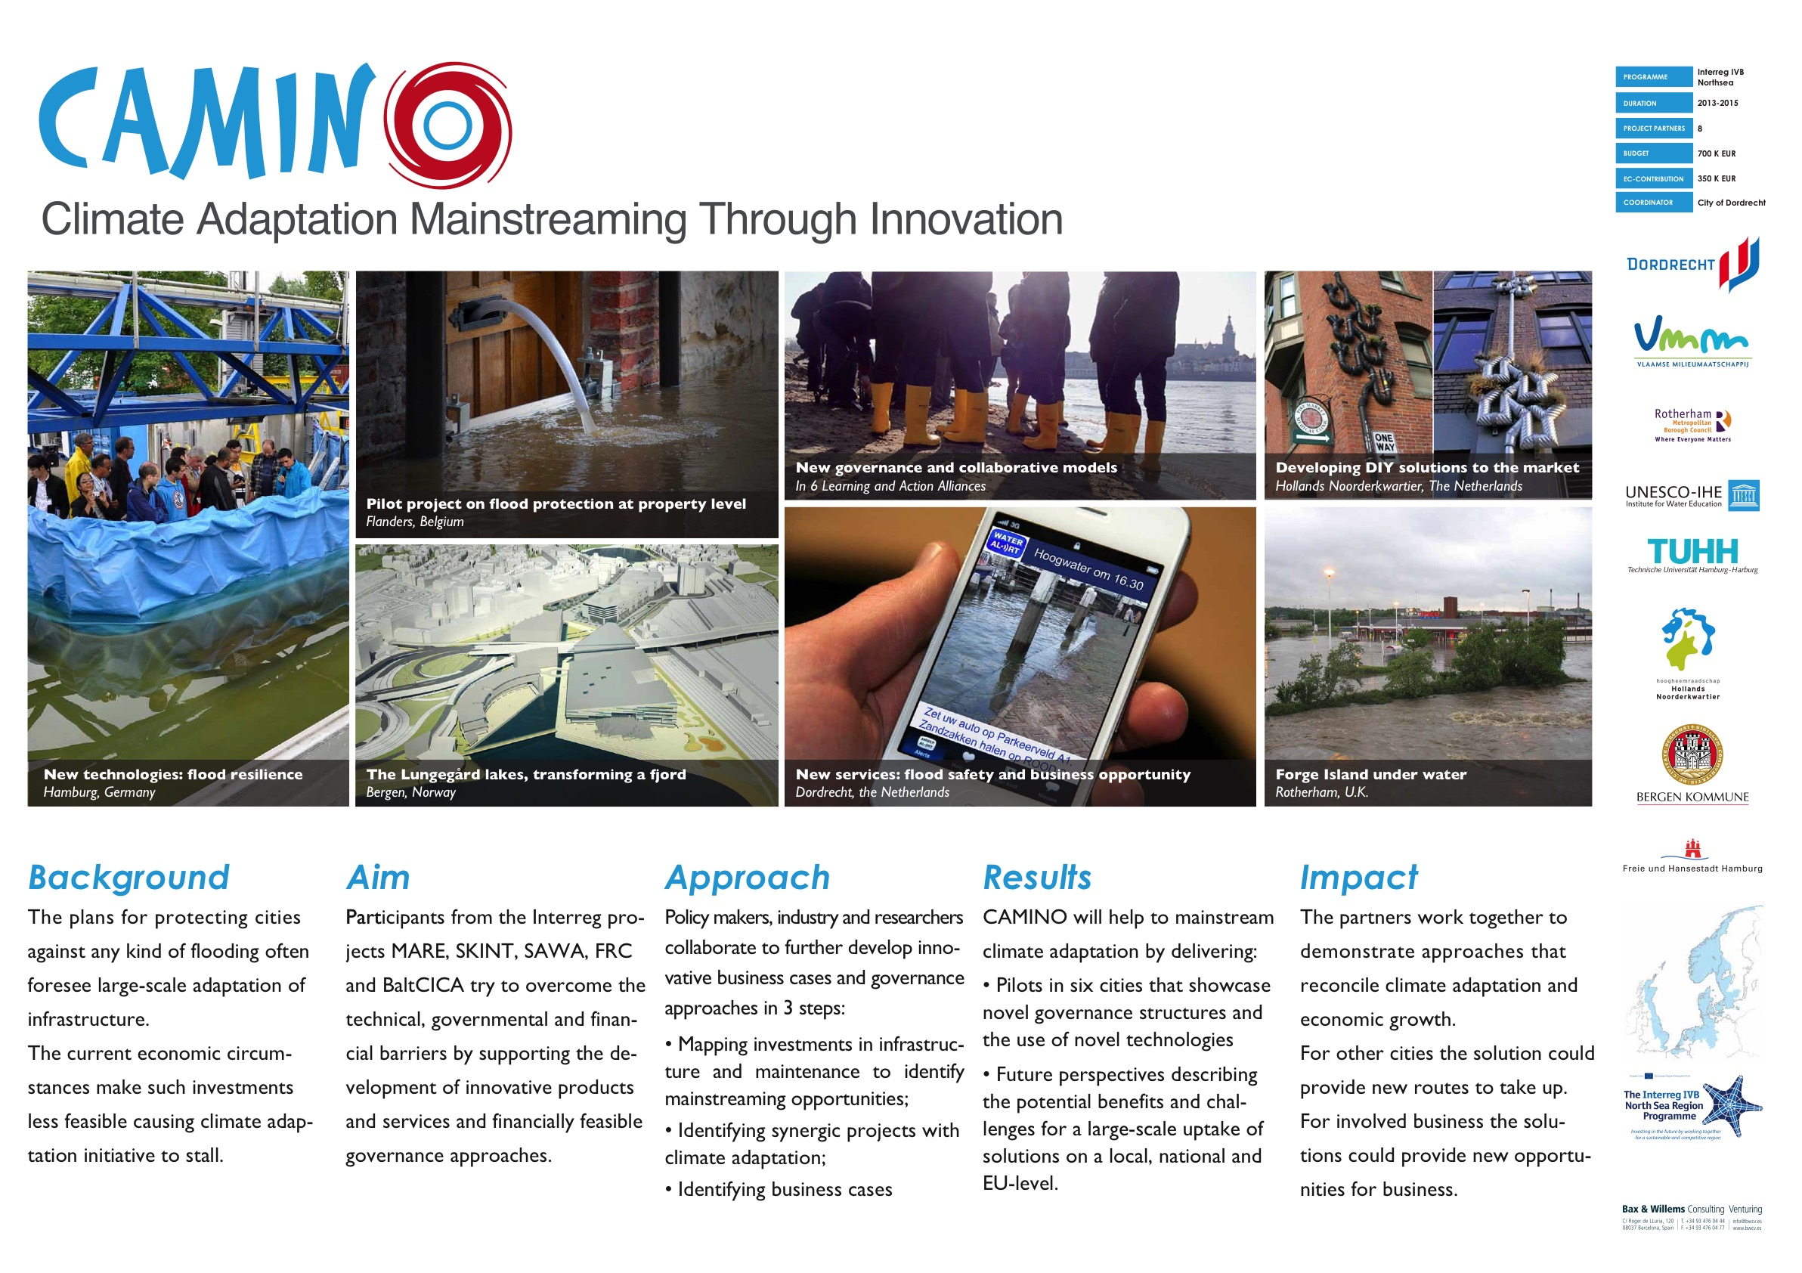

Final conference – background and objectives
CAMINO project´s finalisation was celebrated with a conference entitled ‘Environmental challenges & Climate change opportunities’, which took place on 24-25 March in Antwerp, Belgium. The aim of this event was to exchange best practices & lessons learned that were generated within the framework of international cooperation.
The main objectives of this conference were:
- to provide an insight on emerging environmental challenges and climate change opportunities
- to introduce themes that are identified to become important investment priorities for EU funding
- to offer a platform for (already finished or on-going) projects to present their results
- to offer a possibility to exchange ideas on new cooperation projects
The programme included a large range of environmental and climate topics, including "Funding opportunities for environmental challenges", "Cities of the future", "Protecting today’s environment", "Climate change & society", "Creating business opportunities" and a "Project development/matchmaking workshop”.

Summary of the conference

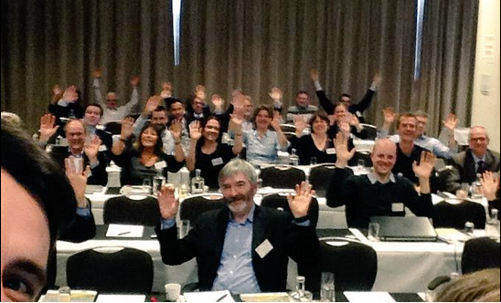

Participants
84 participants took part in the conference, from many different countries of the EU. Roughly 80% travelled to attend the conference from outside of Belgium. Multiple disciplines/backgrounds of the participants included i.a.: water, transport, air quality, finance. Also the sectors were varied: government, science, business, NGOs.

Content
Annexes include:
- Programme
- List of participants
- Presentations of the speakers

Outcomes
Throughout the conference the following issues were discussed and underlined:
- The need to deal with uncertainties and extremes. Urgent action needed despite slowly changing climate.
- Details on EU funding programmes in presentations and websites. Specific points of attention were: focus on 'on-the-ground' results (e.g. pilots), legacy of projects after duration, how you build upon previous results.
- Cities are the place where adaptation takes place. Interrelated challenges from various policy domains, i.a.: air quality, water, energy, transport. Tools and products developed in Interreg 4, now to be implemented (in Interreg 5).
- Mainstream investments with other policy domains. E.g. flood proofing and blue-green infrastructure to be included in urban dynamics or renewal cycles.
- Open data is great opportunity to link policy domains and spatial scale levels. Much data is available, but challenge is to facilitate generation of products and services and deploy it for better service delivery.
- Citizens to be the starting point of dialogue to build low-carbon society. How to harness and facilitate citizen ownership. Examples from Energy, Floods, and broadly Climate Action.
- Practical examples on how to engage and seduce business involvement towards business case development. E.g. certification, standards, branding and financing.

Project development workshop
Projects discussed and further developed within the following thematic groups:
- Carbon reduction and urban mobility
  - SAFE-ICE: Research, Innovation and Business Support for a Low Carbon Economy
  - Low-carbon climate-adaptive urban development
  - Low-carbon water management infrastructure
  - Project on Air Quality
- Adaptation to Climate change
  - Risk based flood (information) management: for real estate, insurance
  - Improving the climate proof of important recreation areas along the Kleine Nete
- Social innovation and living environment
  - Innovation for community resilience
  - Blue Green Infrastructure through social innovation (BEGIN)
- Climate change: business opportunities and governance
  - Validation and Implementation of policies in a multi-disciplinary, multi-stakeholder environment.
  - Building an ecosystem to generate opportunities in open data (for public service delivery)

