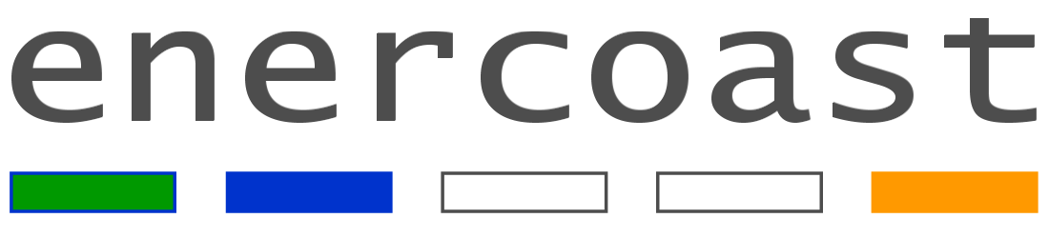
Report

Coastal marine biomass-to-energy potential in Lower Saxony

Radka Ptacnikova
Institute for Chemistry and Biology of the Marine Environment (ICBM), Carl von Ossietzky University of Oldenburg, P.O. Box 2503, 26111 Oldenburg, Germany

Coastal marine biomass-to-energy potential in Lower Saxony
Inhalt

1. Wadden Sea 1
2. Possible sources of algae (marine) biomass in the Wadden Sea 2
a) Algae growth and potential of harvesting from nature 2
b) Seaweed wrack 3
c) Culturing of macroalgae 6
d) Flotsam – a specific coastal biomass 6
3. Summary: coastal biomass of the Wadden Sea to energy 8
4. Literature cited 8
5. Appendix 1: 10

Wadden Sea
Lower Saxony borders the southeastern part of the North Sea, the Wadden Sea, which stretches from the Netherlands along German coast to Denmark. The Wadden Sea is a mudflat intertidal zone, having a shallow body of water during high tide and falling dry during low tide. In the area of the Wadden Sea discharge three large rivers (Ems, Weser, Elbe) that drain altogether area of 212 508 km2, which is for comparison close to 2/3 of total area of Germany. This has two major consequences for the Wadden Sea: 1) lower salinity than that of ocean water (salinity of the Wadden Sea varies typically between 25-30 ‰, whereas ocean average salinity is 35‰) and, 2) high amount of fine sand and clay particles, together with excess of nutrients flushed away from largely agricultural watersheds1,2. Bottom of the Wadden Sea is therefore covered mostly by fine clay and sand, with very limited occurrence of hard substrates. These are formed mostly by secondary hard substrates, such as mussel and newly oyster beds, together with tubes of some polychaetes3,4; along harbors then man-mad concrete piers and sea walls. The water column is during high tide highly turbid, due to permanent disturbance by wind, tides and currents. The coastline along the Wadden Sea is bordered by a continuous system of dikes that have been build and fortified over centuries to protect fertile land and human settlements, the main dikes reach nowadays up to 11 m.
The Wadden Sea is a very unique and valuable ecosystem, providing among other services feeding and resting opportunity for millions of migrating birds. The Wadden Sea along the coast of Lower Saxony has been declared a National Park in 1986; later this area obtained also internationally recognized status of Biosphere Reserve and UNESCO World Heritage Site. The region became sought after touristic destination, though the recreational activities are strictly regulated by the nature protection authorities. For example a direct access to the sea is possible only in constrained stretches of public beaches, piers and on marked trails, whereas entrance into marshlands and salt meadows in between them is prohibited. The area has been further exploited by shipping industry (including recently opened huge container harbor JadeWeser Port), military, fishing, and mussel aquacultures. It is obvious from an overview of existing areal claims by various stakeholders (e.g., here: http://gis.eucc-d.de/waddengis_mapfish/index.htm) that space for a potential new utilization, such as harvesting or culturing marine biomass for obtaining energy, is in the Wadden Sea very limited.

Possible sources of algae (marine) biomass in the Wadden Sea

Algae growth and potential of harvesting from nature
The growth of algae in the Wadden Sea is shaped and limited by the above described environmental conditions. Though there is a surplus of nutrients available in water column, both micro-and macroalgae are restricted in growth by limited light penetration in turbid water ⁵. Though microalgae can in summer months develop relatively high densities⁶, their harvesting directly from the sea is currently beyond any economic feasibility even in localities with significantly denser microalgae blooms ⁷.
Most of macroalgae species require for their growth and development a firm attachment point, which are in the Wadden Sea scarce³ (see above). The macroalgae that do grow on available structures have to cope with low light penetration and relatively low salinity during high tide, exposure to air during low tide and moreover with predation of snails settled on mussel shells³ (Fig. 1). The loss of sea grass beds since the 1930s’ resulted in higher turbidity of water column in the Wadden Sea and therefore sharp decline or disappearance of many macroalgae species⁸. The species occurring in the area are facing mostly sub-optimal conditions, grow slowly and rarely reach size and densities common for example along other shores of the North Sea^{9,10}. Nevertheless, ephemeral green algae from family Ulvaceae (Ulva sp., Enteromorpha sp.) may under favorable conditions form in the intertidal zones of the Wadden Sea so called algal mats, which in early 90’s covered up to 15% of the total area⁴ (Fig. 2). These mats are usually not easy to access, as they typically occur on muddy flats in between navigable channels. The thalli may get loosened, float on the surface and get subsequently caught as a by catch by shrimp fishermen. Besides the green macroalgae, the most dominant species in the Wadden Sea are brown algae Fucus sp., Ectocarpus siliculosus and red algae Porphyra umbilicalis⁴, altogether over 100 species have been documented in the Wadden Sea⁸,¹¹. The growth conditions for macroalgae may, however, gradually improve in future as a consequence of global climate changes, though it is impossible to predict today the exact time horizon of changes to be significant enough¹².

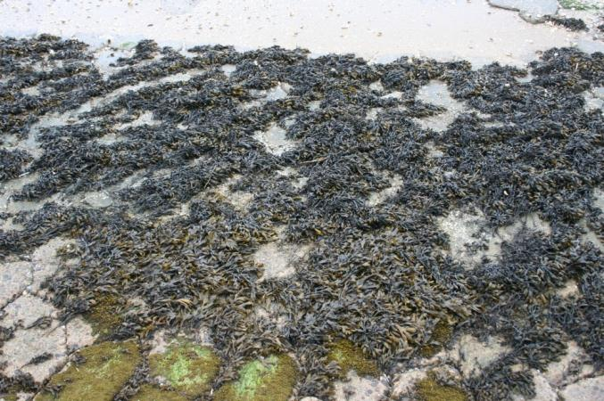
Fig. 1: Brown algae Fucus growing on concrete tiles on beach at Neuharlingersiel

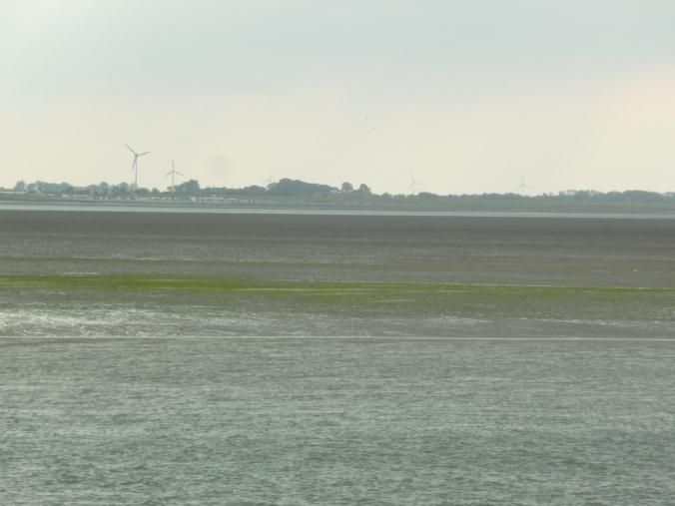
Fig. 2: Green algae mats at Bensersiel

Seaweed wrack
Consequently, the amount of seaweed wrack washed on seashore reflects quantity of algae biomass growing in the nearby sea habitats, i.e. here never reaches quantities common for example on the Baltic Sea coastline¹³ or rocky shores of the North Sea¹⁰ (Figs. 3 and 4).
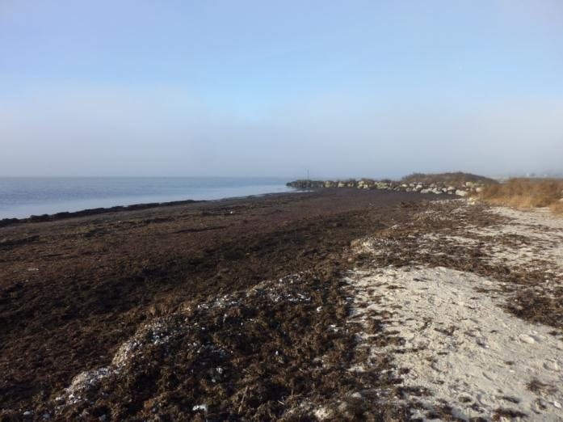
Fig. 3: Seaweed wrack on shore of Baltic Sea close to Trelleborg, Sweden

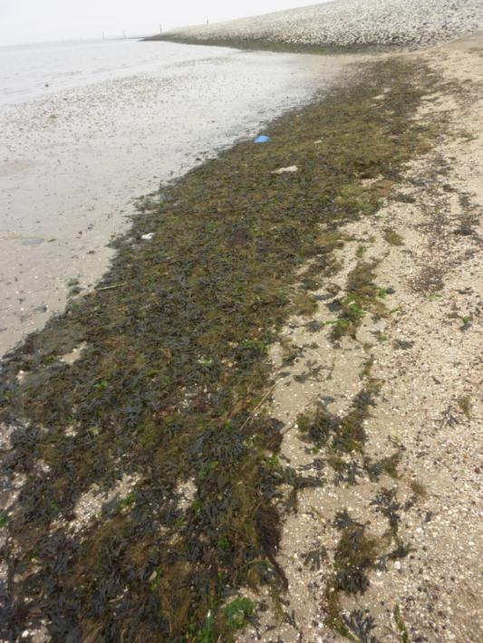
Fig. 4: Amount of seaweed wreck typically available on beaches along the Wadden Sea, here at Neuharlingersiel

As stated already above, a direct access to the shore is in the Wadden Sea area possible due to nature protection only on limited stretches of beaches or harbors. Along the East-Frisian coastline from Norddeich to Burhave are altogether 14 beaches, with total length of about 12 km (see Appendix 1).

M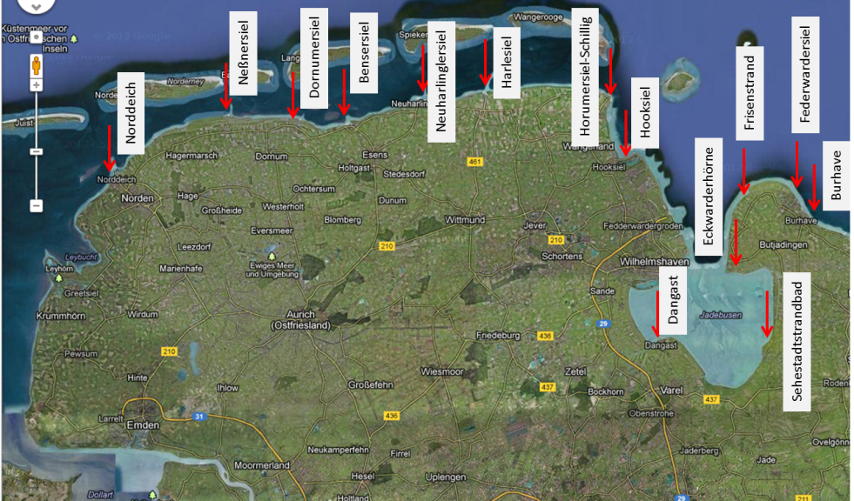
Fig. 5: Map of East Friesland coastline, with marked beaches (see Appendix 1)

The beaches get by demand cleaned in the main tourist season (April-October), including seaweed wrack, the collected material is dumped on landfills and composted. The seaweed wrack is mixed with mussel shells, feathers, wood, human waste and by collecting contains a lot of sand. The overall amount of seaweed wrack is highly dependent on location and exposure of the beaches. Based on information from authorities responsible for beach cleaning, the amount is the highest on beaches at the mouth of the Jade Bay- that is on the west side at beaches Hooksiel-Schillig, and on the east side at Eckwarderhörne and at Friesenstrand in Tossens (Fig. 5). In both areas is the yearly estimate between 100-150 m³ wet weight (of all collected material, including sand). On beaches between Norddeich and Hooksiel-Schillig were reported amounts of maximum 10-30 m³/year/beach, whereas in the Jade Bay the amounts of seaweed wrack on beaches is even lower. This amount, even summed up altogether, is practically negligible for any energy production to speak of, if a biogas fermentation of only algae would be considered. Based on experience from elsewhere, anaerobic digestion of algae biomass yields typically between 0,2 -0,5 m³ CH₄/kg VS ^{14,15}, however, one has to keep in mind that the content of digestable organic substance is in seaweed wrack only about 10%. ¹⁶. Even areas along Baltic coast, where is the seaweed wrack available in significantly higher amount, its sustainable utilization to energy remains questionable and might be economically feasibly only as a co-substrate in biogas production^{17,18}.

Culturing of macroalgae
Though in other areas along North Sea coast, such as in Ireland, Scotland or Norway macroalgae aquacultures have been successfully pursued^{10,19}, the Wadden Sea area is for such projects very unsuitable. First, the environmental conditions do not enable sufficient growth of macroalgae (see above); second, the existing constrains of nature protection authorities and other human activities in the area make a construction of a potential offshore culture facility of any meaningful size extremely unlikely. The only likely realistic project might be coupling remediation of eutrophic basins using macroalgae ^{20,21}.

Flotsam – a specific coastal biomass
In the Wadden Sea area is nevertheless available another potential source of biomass for energy production, which is specific for this area - flotsam. This biomass comes from so called forelands, which are stretches of land between dikes and the sea, present along most of the coastline (Fig. 6). These foreland areas, normally not flooded, have very important role by reducing power of incoming waves at occasional storm floods during winter period and therefore protecting stability of dikes. On forelands grows variety of marshlands and salt-tolerant higher plants. Part of the above ground biomass of these plants dries and dies out during late summer and fall. Then, during winter storm floods this biomass gets torn away and washed out on the dikes. The flotsam contains besides higher plants biomass also various human waste, wood and animal’s rests. To protect stability of dikes by facilitating grass growth and hindering of potential rodents’ spreading, this accumulated flotsam must be soon taken away from dikes, especially if occurring in high amounts²².
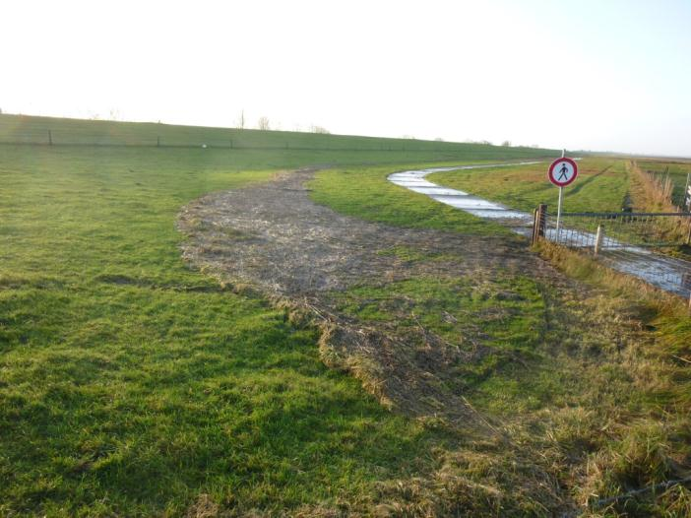
Fig. 6: Flotsam on dike at Sehested Strandbad

The quantity of flotsam vary a lot year to year, depending on frequency and intensity of storm floods, typically between 25.000 to 150.000 m³ on Lower Saxony coast²²,²¹. Here is shown an example of variability of flotsam amount collected on dikes within Jever Dike Authority, where quantity of biomass growing on forelands is relatively high²³ (Figs. 7 and 8).
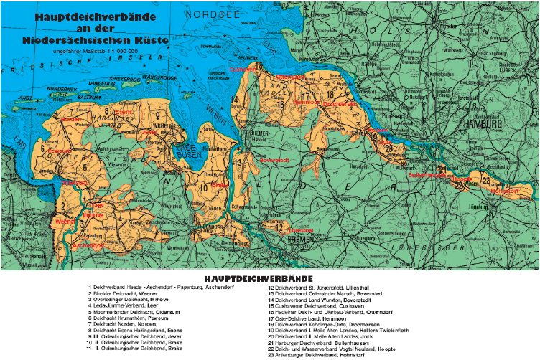
Fig. 7: Coastline under care of Jever Dike Authority

Fig. 8: Amount of flotsam (Treibsel) collected on dikes within Jever Dike authority (in red circle above)

The flotsam used to be burned, composted or shredded, but recently, a question on potential turning of flotsam to energy has been raised, especially after the ‘flotsam-rich’ seasons 2006/2007 and 2007/2008. Several independent studies concluded that feasibility of sustainable and economically viable processing of flotsam to biogas is in principal possible, but rather problematic, due to processing costs (i.e. transport, pretreatment and storage), irregular and unpredictable amount and quality^{16,22,24}. Possibly, flotsam might be used as a co-substrate with other digested substrates, such as manure, sludge or food rests²². The optimal mixing ratios as well as other technology steps have to be first carefully tested in order to optimize biogas production. Currently, measures have been taken to actually reduce amount of biomass on forelands on the first place before beginning of the storm season, by mowing and cattle grazing in late summer^{23,25}. This implies however lower amount of flotsam potentially available for energy production.

Summary: coastal biomass of the Wadden Sea to energy
The potential of utilization of marine biomass to energy per se in the coastline area of the Wadden Sea is obviously not very large and can realistically contribute only slightly to renewable energy production in the region. On top of constrains of algae-to-energy process train in general (see the Algae to energy overview), comes the fact that the amount of algae and other marine biomass available here is in general low and, due to environmental conditions and existing areal claims can’t be assumed to increase considerably. The biomass that gets nowadays collected anyway (seaweed wrack on beaches, by catch and flotsam) might be potentially co-digested to biogas with other available and abundant substrates. The technology must be first carefully tested, starting from storage, pretreatment, proper mixing ratios etc., as the presence of salt, sulphur and heavy metals in marine biomass may easily reduce biogas production. A thorough evaluation of economic feasibility and sustainability should be performed as well.

Literature cited
1. Loebl, M., Colijn, F. & van Beusekom, J. E. E. Increasing nitrogen limitation during summer in the List Tidal Basin (Northern Wadden Sea). Helgoland Marine Research 62, 59–65 (2008).
2. Reise, K., Herre, E. & Sturm, M. Mudflat biota since the 1930s: change beyond return? Helgoland Marine Research 62, 13–22 (2007).
3. Albrecht, A. S. Soft bottom versus hard rock: Journal of Experimental Marine Biology and Ecology 229, 85–109 (1998).
4. Kolbe, K., Kaminski, E., Michaelis, H., Obert, B. & Rahmel, J. Macroalgal mass development in the Wadden Sea - first experiences with a Monitoring-system. Helgolander Meeresuntersuchungen 49, 519–528 (1995).
5. Loebl, M. et al. Recent patterns in potential phytoplankton limitation along the Northwest European continental coast. Journal of Sea Research 61, 34–43 (2009).
6. van Beusekom, J. E. E. & Diel-Christiansen, S. Global change and the biogeochemistry of the North Sea: the possible role of phytoplankton and phytoplankton grazing. International Journal of Earth Sciences 98, 269–280 (2009).
7. Grondahl, F. Removal of surface blooms of the cyanobacteria Nodularia spumigena: a pilot project conducted in the Baltic Sea. Ambio 38, 79–84 (2009).
8. Nielsen, R., Schories, D., Hardtle, W., Reise, K. & Wolff, W. J. Red list of marine macroalgae of the Wadden Sea. Helgolander Meeresuntersuchungen 50, 39–42 (1996).
9. McLaughlin, E., Kelly, J., Birkett, D., Maggs, C. & Dring, M. Assessment of the Effects of Commercial Seaweed Harvesting on Intertidal and Subtidal Ecology in Northern Ireland. 06/26, 1–90 (Environment and Heritage Service: 2006).
10. Bruton, T., Lyons, H., Lerat, Y., Stanley, M. & Rasmussen, M. B. A Review of the Potential of Marine Algae as a Source of Biofuel in Ireland. 1–88 (Sustainable Energy Ireland: 2009).
11. Schories, D., Selig, U. & Schubert, H. Species and synonym list of the German marine macroalgae based on historical and recent records. Rostock.Meeresbiolog.Beitr. 21, 7–135 (2009).
12. Reise, K. & van Beusekom, J. E. E. Interactive effects of global and regional change on a coastal ecosystem. Helgoland Marine Research 62, 85–91 (2008).
13. Trelleborg Marine Inventory 16- 30 August 2009. 1–17 (WAB project: 2010).
14. Horn, S. J. Seaweed Biofuels: Production of biogas and bioethanol from brown macroalgae. 1–102 , VDM Verlag Dr. Muller Aktiengeselschaft & Co. KG (2009).
15. Bruhn, A. et al. Bioenergy potential of Ulva lactuca: Biomass yield, methane production and combustion. Bioresource Technology 102, 2595–2604 (2011).
16. Schneider, H. Energie aus Tang und Algen. -A presentation, Fachhochschule Flensburg (2008). (in German)
17. Nielsen, S. L. Biobrændsel fra alger - potentiale og hype. 1–21 (ENSPAC,University Roskilde, Denmark: 2012).(in Danish)
18. Fredenslund, A. M. et al. Udnyttelse af tang og restprodukter til produktion af biogas. - (Solrod Komunne: 2010). (in Danish)
19. Kelly, M. S. & Dworjanyn, S. The potential of marine biomass for anaerobic biogas production. 1–103 (The Crown Estate: 2008).
20. Schuster, W. & Walter, U. Verbesserung der Selbstreinigung von Küstenwassern durch integrierte Aquakultur. 1–37 (MaRenate & mytilamar: 2009). (in German)
21. Schuster, W. & Schallenberg, J. Grüne Energie aus dem Meer. 1–2 (Deutsche Gesellschaft für Meeresforschung: 2009). (in German)
22. Wonneberger, K. Biosphärenreservate als Modellregionen für Klimaschutz und Klimaanpassung. Teilvorhaben „Treibsel zu Biogas". 1–65 (Wilhelmshaven, 2010). (in German)
23. Sprötge, M. & Bremermann, A. Ökologische grundlagen und naturschutzfachliche Bewertung von Strategien zur Treibselreduzierung. (planungsgruppe grün: 2011). (in German)
24. Ahrens, F., Loewe, K. & Wallmann, R. Treibselnutzung an der Niedersächsischen Küste. (2012). Presentation on 4.International Farming Congress, Papenburg, 13.-15.3.2010 (in German)
25. Gettner, S. Untersuchung des Zusammenhangs zwischen Treibselmengen und Vorlandnutzung an der Westküste Schleswig-Holsteins. Kieler Notiz.Pflanzenkd.Schleswig-Holstein Hamb. 31, 57–71 (2003). (in German)

Appendix 1:
Overview of managed beaches along East Frisian coastline

Municipality | Beaches | Surface | Approx. length [m] | Amount of seaweed wrack collected yearly
Norden | Norddeich | Concrete tiles | 800 | up to 5 m³
Dornum | Neßmersiel, Dornumersiel | Concrete tiles, short sand beach | 340  380 | 10-20 m³ altogether
Esens | Bensersiel | Sandy beach | 800 | up to 20 m³
Neuharlingersiel | Neuharlingersiel | Concrete tiles, short sand beach | 880 | 30 m³
Wittmund | Harlesiel | Concrete tiles | 460 | up to 5 m³
Wangerland | Horumersiel-Schillig  Hooksiel | Sandy beach  Sandy beach | 2700  2500 | 150 m³ altogether
Varel | Dangast | Tiles, Sand | 520 | -
Jade | Sehestadtstrandbad | Bricks | 980 | -
Butjadingen | Eckwarderhörne  Friesenstrand  Federwardersiel  Burhave | Mostly bricks, sand  Stones, asphalt  Stones  Stones, bricks | 150  380  -  880 | 100 m³ altogether

See below pictures characterizing each of the beaches.
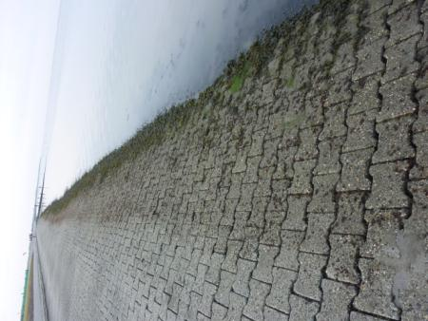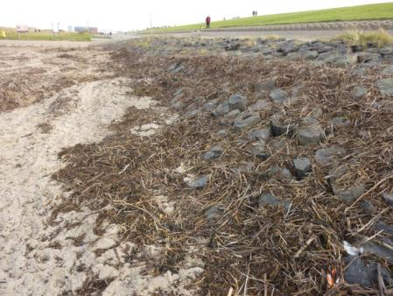
Norddeich

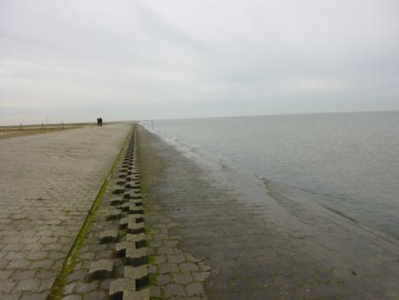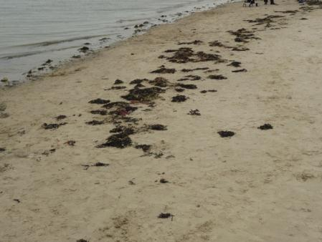
Neßmersiel

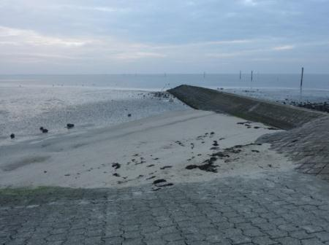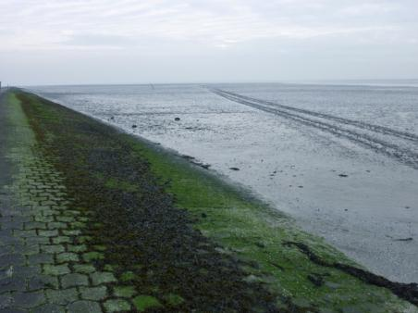
Dornumersiel

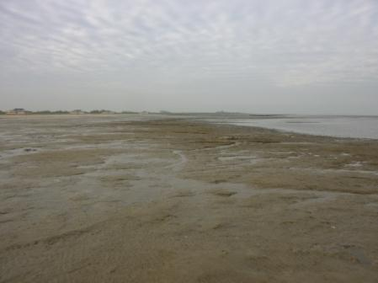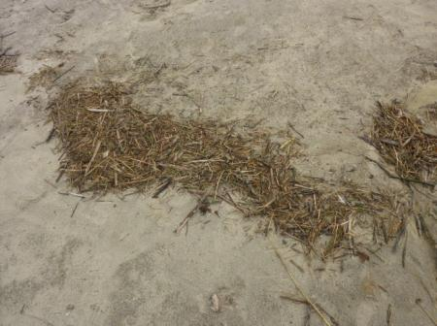
Bensersiel

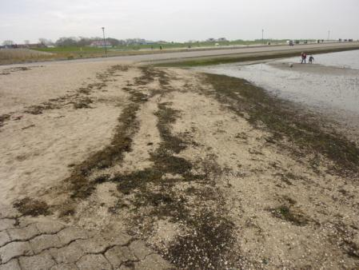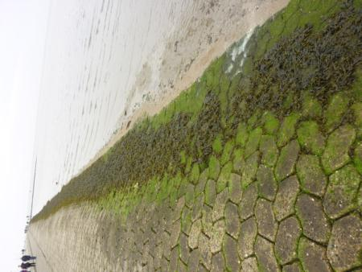
Neuharlingersiel

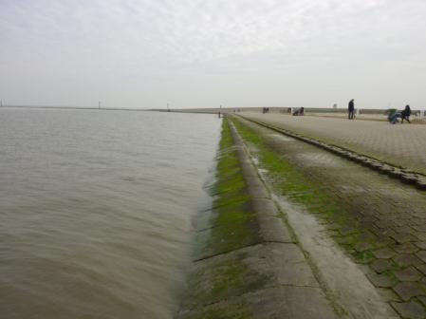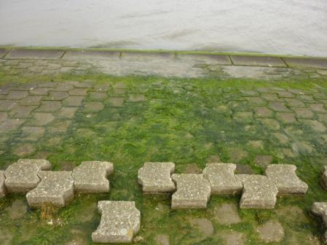
Harlesiel

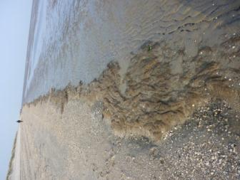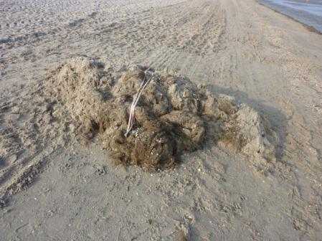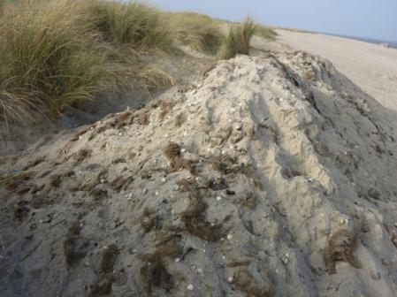
Horumersiel-Schillig

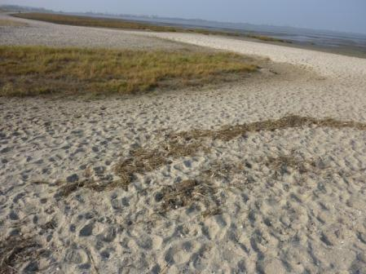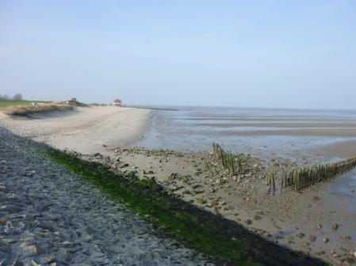
Hooksiel

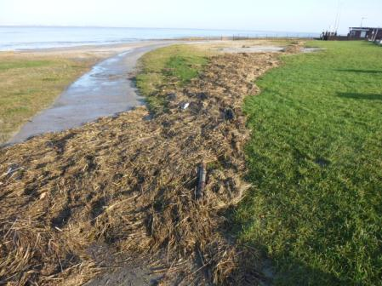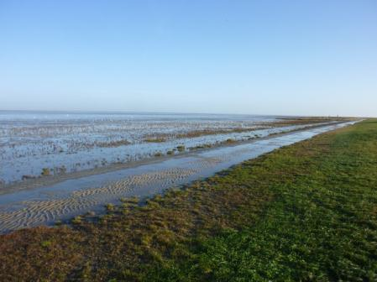
Dangast

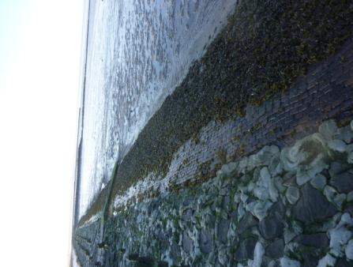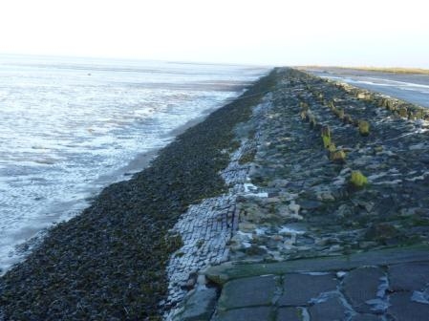
Sehested Strandbad

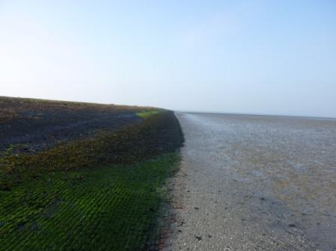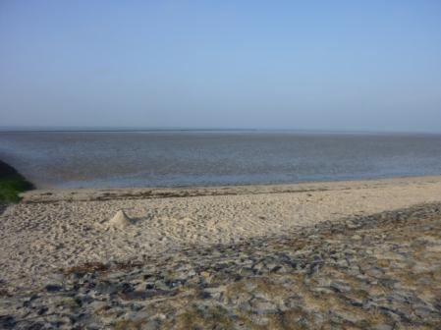
Eckwarderhörne

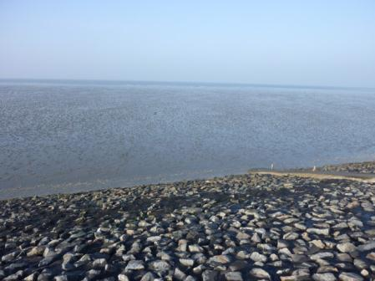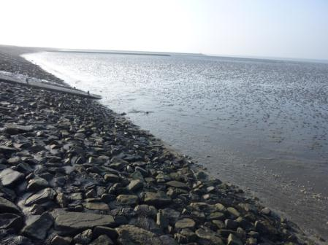
Friesenstrand

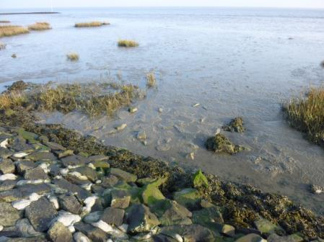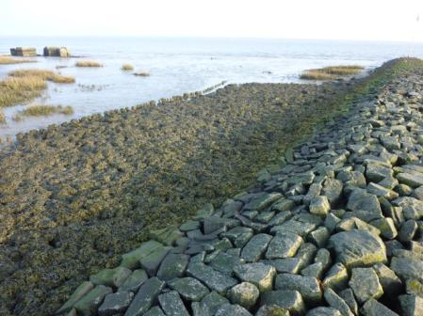
Fedderwardersiel

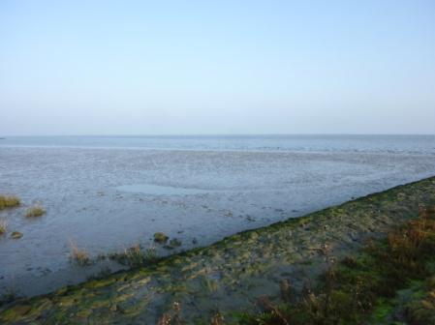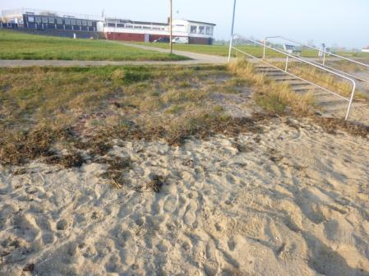
Burhave

