Extended abstract

Algae biomass production under different biotic and abiotic conditions in the context of algae utilization for energy purposes

Wiebke Plöttner, Robert Ptacnik, Radka Ptacnikova
Institute for Chemistry and Biology of the Marine Environment (ICBM), Carl von Ossietzky University of Oldenburg, P.O. Box 2503, 26111 Oldenburg, Germany

Due to scarcity of fossil raw materials, energy and services provided by microalgae draw researchers interest. Their high lipid contents and high growth rates make microalgae in particular attractive for fuel production (Smith et al. 2010).Today, algal cultivations mainly run on monocultures. A lot of effort had been put into stains selection and lipid maximising, but stabile, long-run cultivation of monocultures in large scale applications is challenging (Fishman et al. 2010). Cultures are easily contaminated, especially if nutritious medium is used (Park et al. 2011). Small flagellates can graze on algae and heterotrophic bacteria compete with algae for mineral nutrients.
As an additional aspect, algae can be utilized to remove nutrients from wastewater, which could increase the potential of economic feasibility of large scale cultivation. Recently, much research is done to clean municipal wastewater by microalgae while simultaneously make benefit out of the algae biomass by transforming it into energy (Christenson & Sims 2011, Park et al. 2011 and Pittman et al. 2011).
The idea of our study is to avoid negative effects of contamination and increase available inorganic nutrients for the algae by adding a grazer. A generalist grazer could reduce competition- and grazing-pressure on microalgae. We combined that with the benefit of culturing algae in wastewater. Therefore we grow two diatoms species (Coscinodiscus granii and Odontella sinensis) separately in different media (e.g. enriched with carbon and nutrients by barley grains or biogas wastewater (final concentration 0, 15% and 0,25%) in presences and absence of two heterotrophic flagellates (Oxyrrhis marina and Cafeteria sp.). Preliminary, algae tolerances for light- and biogas wastewater- intensity were tested. Our questions of interest were the following: Does microalgae benefit from presence of a generalist grazer? , Do they produce more biomass in nutrient enriched media and in presents of the flagellates?
In all experiments Odontella sinensis mean biomass during stationary growth phase was predominantly higher than mean biomass of Coscinodiscus granii. Flagellates biomass amount to total biomass 1,3% on average. Significant or tendential higher mean algae biomass during stationary growth phase in the present of Oxyrrhis marina and Cafeteria sp. were reached in some experiments. Effect size of diatom biomass in presence and absence of flagellates during stationary growth grouped by media is shown in Fig. 1. If biomass was significant or tendential higher in treatments with O. marina, carbon content was also higher (Fig. 2). As a result, significant less carbon and nitrogen remained in the detritus in presents of the flagellates. Furthermore, total reached mean biomass differed only slightly between treatments (Fig. 3).
In conclusion, presents of the flagellates had a slightly positive effect on algae biomass repeatedly. No clear trend could be observed concerning an effect on algae biomass by different nutrient contents in media.
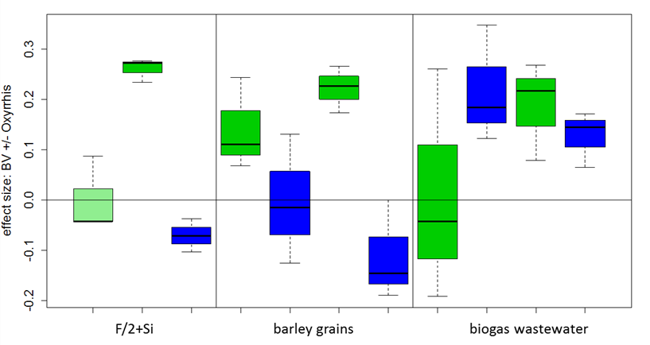

Fig. 1: Effect size of the diatom biomass in presence and absence of flagellates (Oxyrrhis marina and Cafeteria sp.) during stationary growth in different media (F/2+Si, barley grains or biogas wastewater): Boxplot: light green: Coscinodiscus granii (original from culture collection), dark green: Coscinodiscus granii (freshly isolated from the North Sea) and blue: Odontella sinensis; Effect size were calculated according to Hillebrand (2004)
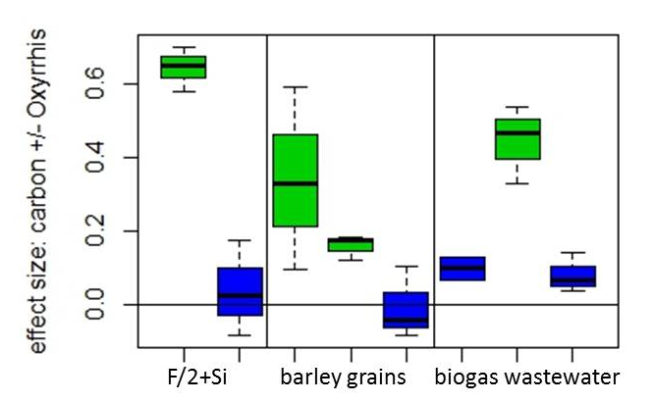
Fig. 2: Effect size of the microalgae carbon in presence and absence of flagellates (Oxyrrhis marina and Cafeteria sp.) at the end of stationary growth phase in different media (F/2+Si, barley grains or biogas wastewater): Boxplot: dark green: Coscinodiscus granii (freshly isolated from the North Sea) and blue: Odontella sinensis; Effect size were calculated according to Hillebrand (2004)

