**Business Plan**

**Årdal Bio AS (ltd)**

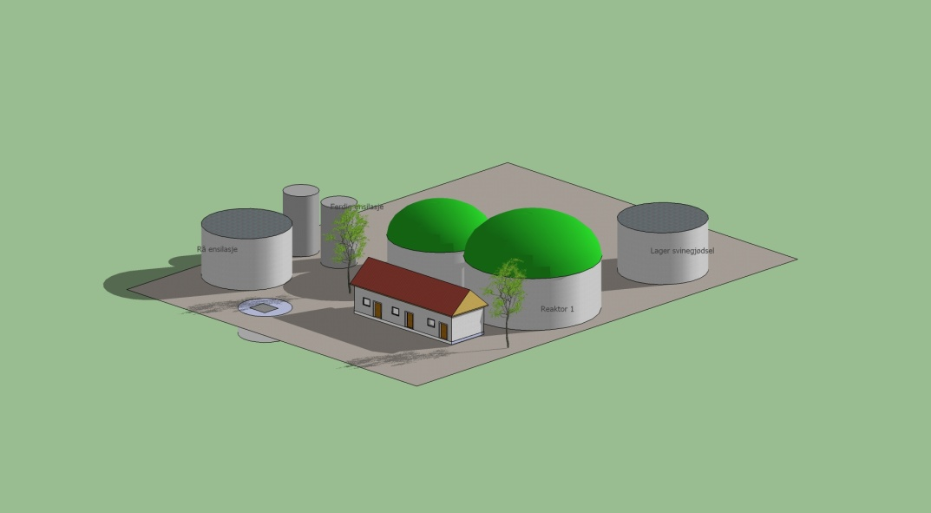

|  |
| --- |
| **Established : 2008**  **Address : 4137Årdal i Ryfylke, Norway**  **CEO : Olaf Vestersjø** |

**Based on the methods of Sustainable Supply Chain Management in Bioenergy**

Written by Olaf Vestersjø, assisted by Kari Sand, County Governor of Rogaland and Inge Håvard Aarskog, Project manager Enercoast – Ryfylke IKS

June 2012

**Content**

1. vision and mission

2. development and regular assessment of strategy

3. quality policy

4. business and quality objectives

5. market analysis (demand profile)

6. organizational and operational structure, including business areas and cooperations

7. identification and design of key processes including needs analyses, design, delivery and elevation

**Vision and mission**

To produce energy to the roofstonefactory Monier in Årdal, and deliver electricity at Lyse energys grid.

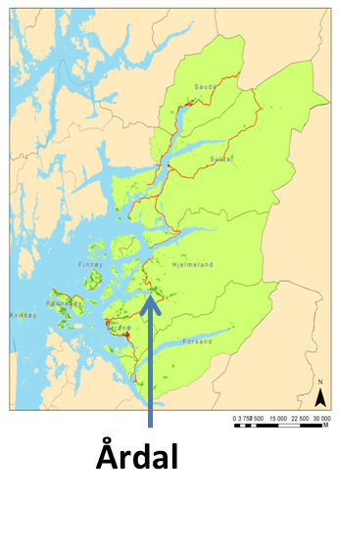

Årdal is a typical rural district mainly based on agriculture, and in new time also on sandindustry and tourism. The manure from all the farms are today spread on the fields that’s used to produce grass for domestic animal food.

Årdal Bio will use the manure to produce heat by methangas.

An important frame for the project is the national agriculture and climate/environment municipality in the County of Rogaland. Rogaland is the mostimportant county in Norway, within animal husbandry (all kinds). The Government and the regional partnership want Rogaland to be in the front of producing biogas based on manure and other organic waste from farmers and gardeners.

The first target in Rogaland is to make three pilots biogas plants.

Årdal Bio ltd wants to be one of these.

**Development and regular assessment of strategy**

Biogasproduction by using manure is a well known process. To produce biogas only based on manure will not give enough biogas, but by using proteins and organic waste with a high level of fat, than the production will be higher. In that case Årdal Bio is looking at Marine Harvests salmonwaste and dead fishes. Ned agreements to secure rawmaterials.

A challenge is to find the effect of using fishensilage in their biogasplant. Årdal Bio`s progress is is based on the report “Evaluation of plans for biogas from fishwaste and manure” by Øystein Svalheim and Tormod Briseid (Bioforsk).

Årdal Bio need fishensilage to get profit in their plant.

Based on this Årdal Bio chose to have one reactor that is running “safe” with 10 % salmonensilage. This reactor will be enough to deliver Monier with heat. A reactor no 2 will be used with more salmonensilage and combinations with different kinds of manure and fishensilage, to get out more gasproduction over time. Årdal Bio are in a dialogue with Fiskå Mølle (oats-shield) and Tau Mølle (pea shell) as an ingredient in the reactor.

In Norway the electrisityprice are low. That are making problems to get good economy in biogasprojects. The department have worked out farmeworkconditions with green sertificates for electrisityproduction.

CHP can get green sertificates, but not if its get money from Enova or Innovation Norway

**Quality policy**

The methods of Sustainable Supply Chain Management (SSCM) have been a quality – and “checkout”-tool for the process; basis for decision for stakeholders and for resource planning. Using the SSCM tool for this project has been valuable. And the conclusion is that the main challenge of the project is to make it profitable – the subsidies must increase. The second challenge is to secure sufficient supply of fish waste. The fish waste is a very attractive recourse at the international marked, but Årdal Bio ltd can reduce the transportcosts from Marine Harvest, and in that case be able to compete.

The biogascalculator that has been developed through the project as a collaboration between The County Governor of Rogaland (Norway) and Innovatum (Sweden), has been a god tool by using the necessary indicators and find the level units that’s needed to build a biogasplant.

**Business and quality objectives**

The production of biogas is based on manure and fish waste. The biogas production is an all-year production and it is very important that the production is regular and predictable. The biogasplant, the farms, the costumers and Årdal as an rural district can get a good ecological and sustainable profile if the acceptance is positive, the plant is running well and the use of the biorest is sustainable.

The plant will optimize the manure (biorest), reduce the use of fertilizer, nitrogen and phosphor to water.

**Market analysis**

Årdal Bio ltd wants to raise the plant at an industry area (Mælsøyrane) near by Årdal Samdrift (collaboration farm), and 700 meters from Monier.

It is important that the customer can see the possibilities by using biogas.

This is from Monier`s webpage: http://www.monier.com/sustainability.html

“To be socially and ecologically responsible while also being economically successful. This principle of sustainability is the guideline MONIER uses for long-term strategic, as well as day-to-day, decisions and activities.”

The heat from the CHP will be delivered to Monier.

The electricity is mean to be used at Monier, the collaboration farm and at the plant. The rest will be delivered to the Lyse grid.

**Organizational and operational structure**

Årdal Bio ltd is owned by four farmers in Årdal: Olaf Vestersjø, Sigmund Tjentland, Tårn Sigve Schmidt og Karsten Sie. The is a fifth farmer that’s probably will join the company later. Three of them are managing a collaboration farm – Årdal samdrift. All want to deliver manure to the plant.

The daily running will take about 2 hours engaged by an operation engineer. The labour costs is estimated to €/kwh: 0,0133 / nok 10 øre (NB: eurokurs = 7,5)

The estimated Transport costs are €/t: 3,2 (NB: eurokurs = 7,5)

The university of Stavanger (UIS) want to place a student (hospitant) by Årdal Bio at the testreactor in 6 months – for free.

Strand college are working with a bioenergystudy, and they are planning a collaboration with testing and steering.

**Identification and design of key processes**

Karsten Sie and Olaf Vestersjø was the initiativemakers to establish Gardsgass ltd as the first deliver of biogasplants in Rogaland. Through years of studies of biogasplants, different studytours abroad and a genuine interest for biogas, the company get the absolute competence they need to build Årdal Bio.

The plan was to start up summer 2112, but because of the economic challenges the plant is on wait. They have not chosen delivers of materials and equipment.

Key figures for Årdal Bio ltd:

Substrates

- 6000 m3 manure from cattle

- 2000 m3 manure from pigs

- 800 m3 fishwaste

Production of gas:

- 53,97 m3 biogas pr hour

- 67,20 % methan in produced biogas

Energy production:

- 1179 452 Kwh electricity

- 1241 528 Kwh heat

Energy price:

- Electricity revenue €/kwh equivalent: average 50 øre /0,0666 euro kwh

- Heat revenue €/kwh equivalent: 0,0666

The prices must compete with the marketprice of electricity.

The degassed slurry:

-Used by the local farmers. The business plan has not calculated any income from the

using of the degassed slurry.

The cost of investments:

-The biogasplant NOK 10 600 000

-The buildingarea (tomtekostnad) NOK 300 000

-Hygienecition, degassed slurry NOK ……

-Gridconnection, electricity NOK 100 000

-Fence NOK 50 000

-Unexpected costs NOK 50 000

=Total costs NOK 11 100 000 EURO 1480 000 (kurs 7,5)

The budget:

