Model Conference/Brokerage Event (20th March, 2012, Edinburgh) as Guideline
The conference and brokerage event on 20th and 21st March 2012 at Edinburgh Napier University can be seen as a model event for future use when promoting clusters of industry through dissemination, brokerage and partnering. The event provided an opportunity for Small and Medium Enterprises (SMEs), Original Equipment Manufacturers (OEMs), Business Development Organisations (BDOs), Provinces and Local Councils, academic and technical institutions to share knowledge and engage in brokerage and partnering to extend business opportunities in and beyond their regions.
The conference event involved presentations by keynote speakers appointed by the partnership to address the European background and sustainable energy issues and was chaired by Caroline Couperus of Groningen Province. Catrinus Jepma, the scientific director of the Energy Delta Research Centre opened with a talk on Energy Innovations in the North Sea Region. This engaging session highlighted some of the challenges and complexities associated with future energy policy in the North Sea Region and the place of innovation. His talk was followed by Councillor Kate Dean of Aberdeen City Council who presented some of the regional initiatives and the role of the North Sea Commission in promoting innovation in sustainable energy. Following interesting discussion over a coffee break the next session focussed on expert and case study speakers from companies and Business Development Associations relating to sustainable energy issues. Ronnie Quinn, a senior development manager for offshore wind at the Scottish branch of the Crown Estates spoke about the strategic work streams associated with safe and efficient development of the offshore wind programme in Scottish waters. John Best, Chief Executive Officer of the East of England Energy Group, described the role of his organisation in generating business from a balanced energy mix. The session concluded with a talk from Bjorn Przgodda, Head of Procurement for RWE, who described the procurement strategies and selection criteria for selecting suppliers for offshore wind projects.
A number of companies and business development organisations made use of the opportunity to erect stands in the main Turmeau hall adjacent to the conference room. The lunch break provided an ideal opportunity for those attending the conference to visit the stands and network with companies and other organisations as well as with those attending the conference. Other rooms, some with internet access, allowed for private discussion to take place.
The afternoon session provided the opportunity for the introduction of the European Business Support Network. The session opened with a talk by Max Hogeforster of the Hanseatic Parliament who introduced the EBSN as a new virtual network for SMEs and described the various aspects of the platform and the way in which it can be used by SMEs, OEMs and BDOs to promote trans-regional European business. The presentation was followed by parallel sessions and workshops detailing aspects of the EBSN. The first stream concentrated on presentations and was opened by Nikolai Lutzky of HWWI Hamburg Institute of International Economics who talked about the role of tendering from the buyer’s point of view. He was followed by Gunilla Edwards of Basildon District Council who described the procurement workshops delivered by her as responding to an identified local business need. The session closed with a talk by Wiebke Bischof from Mariko in Northern Germany and Juergen Goken who spoke of offshore wind regional development in the region of Ems-Achse. Two parallel workshop sessions took place in adjacent rooms. One was given by Mike Pearson who described the purpose of the Self Assessment Tool developed originally by Liverpool Chamber of Commerce and John Moores University, Liverpool and later updated with assistance from Selex UK and Dennso, Germany for use in the energy and maritime sectors. The software was loaded onto laptops available for use by SMEs and other interested parties so that they could identify strengths and weaknesses when seeking trans-regional tendering and partnering opportunities. The workshop was well attended results were stored for subsequent feedback, which has already occurred. The second workshop was given in a separate room by Mario Demets of Syntra West, Belgium to introduce the Food and Health Cluster Self Assessment Tool. There was a weak response to this workshop due to the focus of the event on the energy cluster.
The final session of the conference (prior to the opening of the eubizz.net) was on ‘Forming Alliances with the Enterprise Europe Network and the EBSN’. The session opened with a talk by Paul Edmunds, director of Islandgis, who provide GIS (Geographical Information Systems) analysis, mapping and consultancy services to companies across the Energy, Environmental and Utilities sectors. His talk was followed by Fiona Chan of Emotion Energy Ltd who spoke about challenges and opportunities in the sustainable energy sector and developments in domestic energy. David Hughes from the Intellectual Assets Centre then spoke of the need for SMEs to protect Intellectual Assets such as patents and copyright to safeguard business prosperity. This talk was followed by Jane Watters who spoke about the Enterprise Europe Network and the role played by Scottish Enterprise as well as the way in which this benefits the European Business Support Network. A panel discussion followed after this presentation with members of the panel chosen from the speakers. Caroline Couperus of Groningen Province chaired the session.
The day ended by a visit to the Main Council Chamber at Edinburgh City Chambers to celebrate the launch of the European Business Support Network. Councillor Tom Buchanan was scheduled to do the launch but, due to illness, Jim Galloway, Head of Enterprise and Innovation, gave the welcome at 6pm and launched the EBSN website. The launch was well attended with delegates networking afterwards. Some preliminary meetings took place to prepare for the brokerage event on the following day.
The brokerage event took place on Wednesday 21st March and was organized by Jane Watters of Scottish Enterprise. The event was successful as is evidenced by Jane Watter’s report shown below:

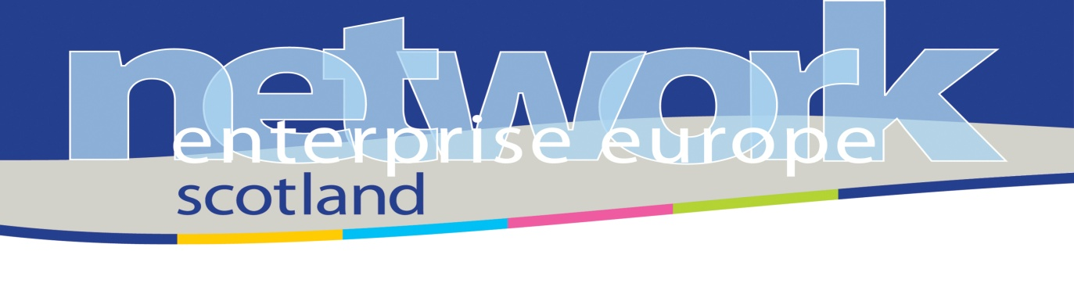

BROKERAGE EVENT
SUSTAINABLE ENERGY CONFERENCE
WEDNESDAY 21ST MARCH 2012
The event was held in response to a request by Mike Pearson of Edinburgh Napier University who was tasked with running a sustainable energy event for the North Sea Supply Connect Interreg project partners and their companies. The business partnering was to provide the opportunity for companies to take part in “targeted networking” to add value to a planned conference programme.
45 companies registered for the partnering event, 20 from Scotland. 18 companies had meetings scheduled, with many not making meeting requests despite reminders regarding the deadlines for this. As a result there were last minute requests for meetings to be set up which the team accommodated where possible.
14 companies took part in meetings. There were several last minute cancellations (most notably the Latvian delegation of 9 companies which cancelled on 20th March). Some contact details have been exchanged by email to that organisations can follow up independently.
12 (of 14) companies gave feedback on the 26 meetings held in total. Despite the low numbers (compared to other similar events), feedback was resoundingly positive:
- almost half of all meetings (45.8%) were rated as excellent with further collaboration planned
- 29% were rated as interesting, with future collaboration possible
- 21% will lead to further contact

Only 4% of meetings were rated as not relevant, with no further contact planned.

Overview/recommendations
Business partnering (or brokerage) events tend to work best to complement other conferences/dinners which bring sector representatives together. Generally EEN Scotland schedule partnering events on the same day as the main conference/trade show/event to ensure that participants’ time is fully utilised.
However, two issues were apparent from informal delegate feedback:
- 2 websites for registration for the conference and partnering event led to some confusion
- 2 separate events over 2 days was not ideal, with some feedback that the partnering would have been more useful if all attendees had been present.
Although the conference programme was a full day, there was feedback that businesses would have preferred the programme to allow half day conference/half day one-to-one meetings.
Final Comments and Recommendations
The combined conference and brokerage event proved to be an overall success and received positive feedback with 77% of a small sample of 17 delegates saying that they found the conference useful (according to a survey carried out by Denise Horn of Edinburgh Chamber of Commerce), particularly the morning presentations. When asked for further comments the following points were made:
1 better organised matching for meetings, the time to book them online was
removed too early.

2 Program ready sooner.

3 make sure the conference is running alongside the brokerage event so that
there are a good number of people passing through the exhibition. It would
be great to entice a few more private companies such as manufacturers and
energy companies.

4 more opportunities to enable introductions

5 Attendance was quite low, I felt and I would have benefited from a wider and
larger body of potential networking opportunities; otherwise, well organised

6 Finish earlier - 5pm after a whole day is too long

7 Not really - probably the preparation time and communication between
partners was not sufficient enough to understand the concept of the
conference and attracting more businesses to attend (esp outside UK)

To conclude we recommend that the format of a future event should if possible be that of a conference running in parallel with a brokerage event. The conference session in the morning seemed to be very successful with invited speakers addressing the European background as well as the regional issues of the conference followed by focussed experts and case study speakers from companies and Business Development Associations relating to the key themes. We think that the format of the afternoon session should also remain with an introduction to the EBSN followed by parallel sessions and workshops detailing aspects of the platform. We think that these presentations and workshops could also run in parallel with the brokerage event where only a few companies would be absent from the conference for a short period of time (say 30 minutes) for each partnering meeting. This could continue through the afternoon and then into the next day if necessary, but it probably would have been possible for both the conference and brokerage event to finish by 5pm given the number who actually attended. There were also some lessons learned from the way in which delegates registered for the combined events. In future it should be possible to register for both events in one registration form. There were also some issues concerning the dropout rate. Over 90 registered for the conference but only 70 appeared. If there was some way of charging an entry fee this may have decreased the dropout rate.
Mike Pearson
Edinburgh Napier University
5th April 2012

- Self-evaluation of EBSN partners support activities
- Project partners supported the brokerage event as agreed during the previous working meeting in Tallinn. It means they contacted companies at their regions to invite/convince them to participate in the B2B Matchmaking event organised by EEN on the 21st of March in Edinburgh.
- Companies from Latvia, Sweden, Belgium, Bremen and UK registered their self to the matchmaking platform. Unfortunately Bremen and Latvian companies did not travel to Edinburgh because there were not interesting matches for them. Companies from the Netherlands, Estonia and Poland did not register for the event from the very beginning as they did not find any potential cooperation partners for them in the platform.
- In general the event was well organized according to the standards of EEN. However this is not the way how EBSN wants to operate. In a first impression the event did not lead to a success but it is necessary to wait for the feedback from the participants in order to get a final conclusion. A major commitment of the EBSN hosting partner(s) to match the companies from other regions with local companies is desired. The participation of intermediaries (BDOs) representing companies is the option that EBSN partners has to adopt if few appointment were arranged for they companies. In this way, local companies which booked an appointment with those companies would not have an unpleasant surprise: cancelation of the appointment only one day before.
- After an internal discussion of the so called “Subgroup 7” the following basic rules for supporting matchmaking events were agreed:
- A matchmaking event is not only setting a web-page and waiting for the best. There should be a local commitment by the hosting partner for searching and convincing local companies.
- Partners coming from other regions have to commitment at least theirself to participate as intermediaries representing some companies during these events.
- Combination of the matchmaking event with a relevant event e.g. international conference is desired.
- The EBSN members are still in a learning process for supporting/organizing matchmaking events. Therefore it is not possible to define at this moment the key for successfully event. This process will continue and the next real test will take place in Bremen (June 2012) and Hamburg (September 2012).
- Jesús Zepeda Juárez
- WFB Bremen GmbH
- 27th April 2012

Appendix

North Sea Supply Connect Work Package 3 Task 3.5 Supply Cluster Guidelines (9.3.2011)
The supply cluster guidelines are to support communication and training and provide a summary of cluster information for events and guidelines for training. The guidelines summarise the contents of Work Package 3 so that they can be communicated to the public and bodies interested in using the materials. The guidelines will also coordinate with the Baltic Supply project with pointers to the IT consultant on how to use the cluster guidelines. As such this version of the guidelines is a preliminary document for discussion and development by the partners and consultants. Further updates are expected as the project and the Business Development Platform (BDP) develop.
Introduction
The North Sea Supply Connect (NSSC) project has as one of its objectives the design and implementation of a portal for registration and access by Original Equipment Manufacturers (OEMs) and Small and Medium Enterprises (SMEs) across the North Sea region. The key areas of interest identified by the project are Maritime, Energy and Health & Food. Task 3.1 of Work Package 3 identifies the clusters of such industries and their core competences within each of the regions Bremen, Basildon, North Netherlands, West Flanders, Emden Leer, Mariko, Arvika and Edinburgh Chamber of Commerce. Task 3.2 addresses the main applications and needs identified by their supply markets. The partners have been asked to give information where possible on specific companies, both OEMs and SMEs, in their regions. The purpose is to assist in the next stages of the project which involve the formation of relevant company registers attracting innovative developments and products in the core cluster areas of Maritime, Energy and Health & Food. Once companies have been identified the next stage of the project is the formation of a portal with the express purpose of matching companies (OEMs and SMEs) suitably to increase trans-regional trade. Company registers are already a common feature of e-business, but many registers are used mainly to trace companies, often for legal purposes. A British list of company registers across European and other countries can be found at the website http://www.rba.co.uk/sources/registers.htm . To access a prospective trading partner a company needs to carry out a dedicated search of such company registers to identify suitable partners in a business venture. Even then, a searcher is unlikely to find a match in a key innovative area of application and even less likely to get a trans-regional match. Some websites (though not registers or even portals) do invite interest across different country boundaries. A key site of interest is the Enterprise Europe Network (EEN, http://www.enterprise-europe-network.ec.europa.eu/index_en.htm ). This network can be hosted and maintained by organizational partners in regions. One such host is Scottish Enterprise who act as a broker between SME suppliers and OEM buyers (http://www.enterprise-europe-network.ec.europa.eu/about/branches/UK/Glasgow ). Another site is the Scotland Europa site (http://www.scotlandeuropa.com/), which promotes trans-regional European trade for Scottish companies. This site does, of course, mainly promote the selling of Scottish goods in Europe, rather than European goods in Scotland. Such websites also usually require an enquirer to make a contact with an intermediary manager through e-mail or direct means. Other websites overcome this latter problem by organising an event website with exhibitors, match-making, opportunity and funding and support zones (http://www.scottishtechnologyshowcase.com/) where individuals and companies are encouraged to engage. This is in some respects close to the portal design which we aspire to in the NSSC project. However, the website refers to a one-off event rather than a continuously managed portal. It has similarities with the ‘Meet the Buyer’ event described by the Basildon partner (http://sites.google.com/a/northseasupplyconnect.eu/intranet/). The Mapergy tool (http://www.eeegr.com/mapping/index.php) provides a valuable resource for identifying companies engaged in renewable energy in North East Europe and is used by the National Renewable Energy Company (Narec http://www.narec.co.uk/ ) to map the renewable energy centres in northern Europe. The Baltic Cooperation project (http://www.balticcooperation.eu/UNIQ128464154023319/SES88545740/lang1/doc4039A.html) is also an important point of reference for the development of the NSSC register. These websites and portals have been developed with European funding and could form the basis for the design of the NSSC portal.
North Sea Supply and Baltic Supply aim at the joint establishment of a cluster in order to facilitate the direct contact between end-users and SMEs as well as to promote the co-operation between SMEs in Europe through the following services:
- Networking (information exchange and brokerage events)
- Cooperation for development of products / research activities (between SMEs and OEMs as well as between SMEs)
- Marketing platform (shop-window and active promotion e.g. in trade fairs)
- Training and coaching for SMEs e.g. preparing a bid for a EU-founded project or preparing a business plan for taking over RTD activities from OEMs.
Another valuable source of information is the ‘Business Development Whitepaper’ on the intranet (Work Package 4 https://sites.google.com/a/northseasupplyconnect.eu/intranet/documents/wp4 ) which is currently for discussion purposes only. The paper raises issues concerning the design of the Business Development Platform. One design under consideration is the ‘hub and spoke’ model. According to this design the existing structure of the project partnership can be utilized and integrated in a combined organization of a central host for the BDP and de-central service delivery units (provided by dedicated partner organizations). The above EEN site may provide a useful illustration, since the hub is provided by the EEN with ‘spokes’ serviced by partner organisations

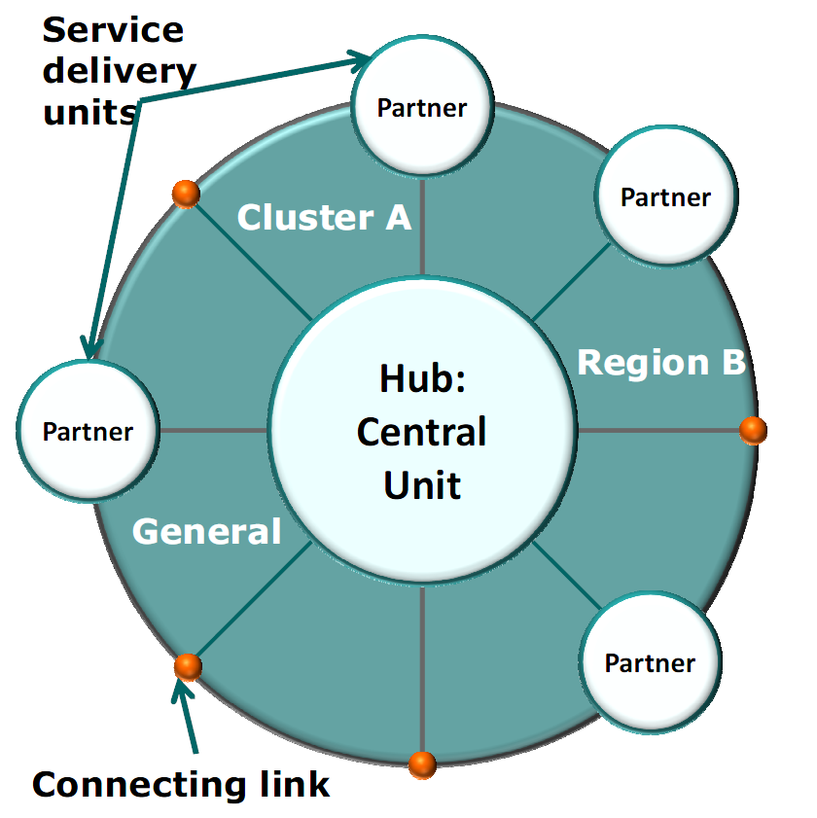
Figure 1 Hub and Spoke Design
such as Scottish Enterprise. The Business Development Platform could make use of this existing network to identify specific links in its target markets and clusters.

Maritime Supply Cluster User-friendly Guidelines for practical use by IT Consultant (and for development and later use by SME&OEM and cluster management organisations)
The Maritime Supply Cluster is the subject of a coordinated effort by the North Sea Supply Connect and the Baltic Supply projects. The projects have formulated a shared approach to define target markets in the maritime industry. With the North Sea Supply Connect project consortium, our aim is to set up a platform to bring together and support innovative SME’s in order to let them participate in large procurement procedures initiated by large OEM’s and focussed on strategic emerging maritime markets.
These selected markets are:
- Green and smart Shipping
- Multi-purpose use of the sea: construction and servicing of offshore projects
- Security, Safety and surveillance
- Off-shore (Cross clusters combining with energy and food) *
- Supply *
- Technology*
We have identified that innovative SMEs have the best opportunities for access to supply chains in emerging markets. For this reason we decided to target the so called “innovative markets”. Those markets are characterised by high innovative and sophisticated products and small batches. The two characteristics would allow the cooperation between specialised SMEs and OEMs.
*These are the markets defined by the Baltic Supply project, which overlap in some areas

Energy Supply Cluster User-friendly Guidelines for practical use by IT Consultant (and for development and later use by SME&OEM and cluster management organisations)
North Sea Supply Connect strives to connect SME suppliers and manufacturers of energy production, distribution, consumption and energy efficiency technologies from all countries along the North East Corridor, specifically within the North Sea region. The partnership intends to activate SMEs with a high competency in energy efficiency or in developing effective energy transformation systems. Procurement officers of a wide range of energy industries will find creative SME suppliers through North Sea Supply Connects' tendering and partnering services.
The North Sea Supply Connect and Baltic Supply projects create new business opportunities for SMEs located in the North and Baltic Sea Regions. The perspective of collaboration between OEMs and SMEs based on the eco-energy innovation and supply target markets are:
- Wind Energy.
- Energy cogeneration ( Biomass)
- Bio-energy conversion
- Renewable Energy Sources (RES) Offshore Wind Energy

Health & Food Supply Cluster User-friendly Guidelines for practical use by IT Consultant (and for development and later use by SME&OEM and cluster management organisations)
The Health and Food Supply Cluster is the subject of a coordinated effort by the North Sea Supply Connect and the Baltic Supply projects. The projects have formulated a shared approach to define target markets in the health and food industry. The growing demand for sustainable and safe food is providing significant opportunities which, combined with food trends like organic foods and functional foods serves a focus for collaborate innovation. The aim of North Sea Supply Connect is to create partnerships between SME's and suppliers in the food sector, thereby facilitating SME's access to large procurement and improving SME's capacity to participate in tendering - mainly in upcoming markets.
The selected priority supply markets in this cluster are the three emerging markets:
- Organic food processing
- Functional and convenience food
- Food safety and quality
During our research into the food industry in the North Sea and Baltic Sea Regions, we have found a distinctive focus on these selected supply markets from companies.

