Alice Mathers and Mel Burton
20/09/2012

Department of Landscape, University of Sheffield
Developing an Area Based Approach to open space management
An summary of the second stage focus group evaluation of the East Green and Open Spaces Strategy (GOSS) process

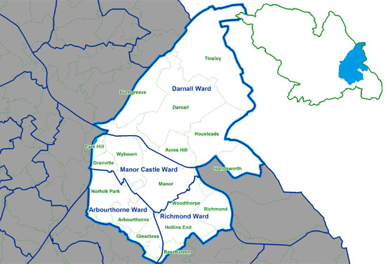

Purpose: One year on from creation of the East GOSS Steering Group (which first met in September 2011) this focus group aimed to capture the collective experiences of, and outputs from, development of an Area Based Approach in the East Community Assembly Area of Sheffield

Methodological note: This focus group formed the second formal evaluation by MP4 (University of Sheffield) of the Steering Group process, following individual semi-structured interviews with Steering Group members in January 2012 (four months in to the process).

Focus group participants (8)
Sue France (Green Estate)
Roy Moseley (Sheffield Wildlife Trust)
Tamsin Auckland (Regeneration Team, Sheffield City Council)
Liz Ballard (Sheffield Wildlife Trust)
Matt Barlow (Parks Service, Sheffield City Council)
Stuart Turner (Parks Service, Sheffield City Council)
Claire Taylor (Parks Service, Sheffield City Council)
Brett Nuttall (Green Estate)

Focus group facilitation (2)
Mel Burton (Department of Landscape, University of Sheffield)
Alice Mathers (Department of Landscape, University of Sheffield)

PART 1: East GOSS questions

1. Communication
How successful has communication of the EGOSS been during this time, please describe?

- Has been a point of weakness
- Whilst there is a lot of communication at the meetings, in between there is much less
- A lack of ‘joined up’ communication to connect the City and East GOSS, both of which suffer from a low profile
- Everyone has limited time to give, which means communication about the EGOSS is limited
- Communication is better (between meetings) within the working groups i.e. those working together on a detailed action
- There is still a need for actions to be followed up in a more systematic way – otherwise individuals panic in the immediate run up to a meeting to complete assigned tasks
- The SG really needs a clear leader (driver/advocate) – but no one as yet has stepped forward to take on this role. Resourcing for this to happen might be an incentive for someone to step forward
- Sharing data is still a problem due to software compatibility and time
- There is a danger that without a better communication strategy the group may lose members between meetings and that momentum declines
- Postponement of the EGOSS Community Event is a reality and a concern, but dedicated time is needed to arrange, communicate and make this a success
- Where sharing of information has occurred this has been very positive – and communication between individuals in different organisation is better as a result

2. Motivation
How motivated is the group to continue with the EGOSS process, and what has affected this?

- Everybody’s ‘heart’s in the right place’
- The danger of NOT working together - there is an awareness that SG members have ‘seen where we’ve come from’ (a point of disparity) and are all aware that progression can now only happen together (collectively)
- Green Estate: understanding the added value of the group
- SCC Parks motivation: a way to deliver the GOSS, find out about and attract funding together (i.e. the Local Growth Fund), identify gaps and missed opportunities
- SWT motivation: sustaining and developing the ecological network
- Motivation (all): awareness of the danger of MISUSE of limited resources available if they don’t work together
- SCC Regeneration motivation: for new SG members the EGOSS meetings are really valuable as they provide an insight into what’s going on in the East Area. New staff may not be aware of the complexity of this, as predecessors have moved on (changed roles) without passing on such information. It’s a way to ensure knowledge does not get lost!

3. Membership
Has membership of the EGOSS Steering Group (SG) changed during this time, if so how?

- It still is a ‘coalition of the willing’
- Organisational membership of the SG has not changed much over the year. However individuals have moved on and been replaced (4 different staff have attended EGOSS meetings from the SCC Regeneration Team)
- SWT presence at SG meetings has increased – now Roy and Liz
- Having the involvement of the Community Assembly (political dimension) through Angela is still seen as key
- Groundwork were invited to be involved but have never attended
- Membership may need to be extended but should be careful handled (due to individual motivations). This might include Registered Social Landlords and the Housing Company (SHA)
- The Regeneration Team are key to the link with housing

4. Ownership
How do Steering Group members experience ownership of the EGOSS process, one year on?

- SG ownership of the EGOSS is still strong, but it is a BIG task for a SMALL group
- A clearer message would aid ownership and understanding of the EGOSS outside the SG
- SCC are very committed to it through the GOSS connection
- Ownership could have been improved though through completion of the Quality Audit for green spaces and if the EGOSS Community Event had been held/ was still scheduled to go ahead (these are identified as key ownership building tools)
- Green Estate feel that the EGOSS would have a better profile if the GOSS was more widely recognised
- Need for strong East Assembly backing to politically support the EGOSS

5. Methods
What methods have been employed during the year to aid development of an Area Based Approach?

- Meetings – SG and working group meetings
- Mapping – sharing data
- Working on the Sheffield Standard
- Play Conference

6. Expectations/Outcomes
Have your expectations of the EGOSS process being met, and if so how?

- Expectation met: Has been successful in identifying issues in the area
- Outcomes: Should be greater focus how the EGOSS SG has helped issues move on – recognising and recording outcomes
- Outcomes: Need to communicate priority actions from the first year, and question if these are still relevant (not all SG members are aware of the original EGOSS priorities)
- Outcomes: Need to more clearly identify outcomes i.e. what has happened on the ground, what has been found out, what has been worked on together. There have been several outcomes but these have not been communicated to others.

PART 2: East GOSS Network

- Please draw the initial network of members involved in the East GOSS when it commenced a year ago in 2011.
- Please mark on the network any members that are no longer involved in the East GOSS.
- Please add to the network new members who are now a part of the EGOSS in 2012.
- Please add to the network any potential members who the EGOSS Steering Group you feel should now be involved.
- Please rank the three key organisations within the East GOSS network.

Below is the collectively decided picture of the EGOSS Steering Group network one year on (September 2012), as created by EGOSS Steering Group members.

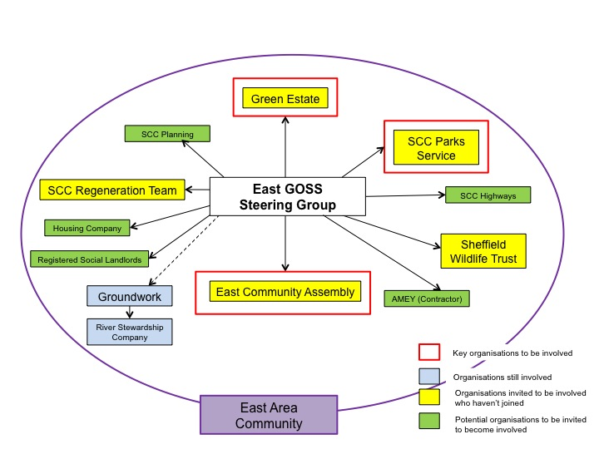

Evaluation Summary

The focus group identified benefits from the EGOSS approach, in particular the map and gap exercise and sharing information. They could see the potential of the EGOSS to deliver added value to green space delivery across the area, particularly in terms of identifying possible multiple benefits of the green spaces, prioritisation key issues and sites and identifying opportunities. However it was recognised that the key issue is the capacity of the group (through the input of individual members) to deliver the priority actions. These were aspirational and may need to be revisited and adapted in line with the group’s current capacity. The issues that were identified in the interim evaluation remain; that of poor communication, lack of clear leadership and remit for the group. In its current form the SG offers a useful opportunity to share information and focus for some joint actions but requires greater political validation and support (via the GOSS) in order to achieve more.

